





ក្រសួងអប់រំ យុវជន និងកីឡា

វិទ្យាស្ថានបច្ចេកវិទ្យាកម្ពុជា

ដេប៉ាតឺម៉ង់ ទេពកោសល្យព័ត៌មានវិទ្យា​ និង​ទំនាក់ទំនង

របាយការណ៏ចុះកម្មសិក្សា វិស្វកម្មឆ្នាំទី ៤​

ប្រធានបទ : ប្រព័ន្ធគ្រប់គ្រងក្នុងការប្រើប្រាស់វាយហ្វាយ

និស្សិត : វ៉ែន​ ថុន

ឯកទេស : វិស្វកម្មព័ត៌មានវិទ្យា និងទំនាក់ទំនង

គ្រូទទួលបន្ទុក **:** ណុប ភារម្យ

ឆ្នាំសិក្សា : ២០២២-២០២៣

**MINISTERE DE L’EDUCATION,**

**DE LA JEUNESSE ET DES SPORTS**

**INSTITUT DE TECHNOLOGIE DU CAMBODGE**

**DEPARTEMENT DE GENIE INFORMATIQUE ET COMMUNICATION**

**RAPPORT DE STAGE D’INGÉNIEUR  
DE QUATRIÈME ANNÉE**

**Titre : La sécurisation du système de gestion des accès sans fil**

**Etudiant : VEN Thon**

**Spécialité : Génie Informatique et Communication**

**Tuteur de stage : Mr. NOP Phearum**

**Année scolaire : 2022-2023**



ក្រសួងអប់រំ យុវជន និងកីឡា

វិទ្យាស្ថានបច្ចេកវិទ្យាកម្ពុជា

ដេប៉ាតឺម៉ង់ ទេពកោសល្យព័ត៌មានវិទ្យា និងទំនាក់ទំនង

របាយការណ៏ចុះកម្មសិក្សាវិស្វកម្មឆ្នាំទី ៤

របស់និសិ្សត: វ៉ែន ថុន

កាលបរិច្ឆេទការពារនិកេ្ខបបទ: ថ្ងៃទី ១៧ ​ ខែ​ វិច្ឆិកា ឆ្នាំ ២០២៣

អនុញ្ញាតឲ្យការពារគម្រោង

នាយកវិទ្យាស្ថាន:

ថ្ងៃទី ខែ ឆ្នាំ ២០២៣

ប្រធានបទ : ប្រព័ន្ធគ្រប់គ្រងក្នុងការប្រើប្រាស់វាយហ្វាយ

សហគ្រាស : វិទ្យាស្ថានបច្ចេកវិទ្យាកម្ពុជា

ប្រធានដេប៉ាតឺម៉ង់ :​​​ ​លោក ឡៃ ហេង ​

សាស្រ្តាចារ្យដឹកនាំគម្រោង : លោក​ ណុប ភារម្យ

អ្នកទទួលខុសត្រូវក្នុងសហគ្រាស : លោក ឃាង ហុងលី

រាជធានីភ្នំពេញ​ ឆ្នាំ២០២៣



**MINISTERE DE L’EDUCATION,**

**DE LA JEUNESSE ET DES SPORTS**

**INSTITUT DE TECHNOLOGIE DU CAMBODGE**

**DEPARTEMENT DE GENIE INFORMATIQUE ET COMMUNICATION**

**RAPPORT DE STAGE D’INGÉNIEUR DE QUATRIÈME ANNÉE**

**DE M. VEN Thon**

**Date de soutenance: le 17 Novembre 2023**

**« Autorise la soutenance du mémoire »**

**Directeur de l’Institut: **

**Phnom Penh, le 2023**

**Titre :** **La sécurisation du système de gestion des accèss ans fil**

**Etablissement du stage : Institut de Technologie du Cambodge**

**Chef du département : M. LAY Heng ______­­­­­­­­­­­­­­____________**

**Tuteur de stage : Mr. NOP Phearum ______**

**Responsable de l’établissement : Mr. KHEANG Hongly ______**

**PHNOM PENH​, 2023**

# ACKNOWLEDGEMENT

As a fourth-year engineering student at the Institute of Technology of Cambodia, I must participate in a minimum two month for internship program. Additionally, it provides opportunity for me to apply the knowledge acquired during my academic studies to real work and get new experience, especially in Natural Language Processing.

First of all, I would like to express my deepest gratitude to my parents who always give me all kinds of support, advice to me and thankfulness to the people who gave me support and involved in my academic journey.

**H.E.** **Dr. PO Kimtho**, Director of Institute of Technology of Cambodia for his excellent administration of the organization and good cooperation with the partner universities at the local, regional and international levels to improve the standard of the training of engineers and senior technicians.

**Mr. LAY Heng**, Head of the Department of Information and Communication Engineering at the Institute of Technology of Cambodia that provides students the opportunity to have the internship to improve the technical skill and his good management under his hierarchy at the department.

**Mr. NOP Phearum**, my academic supervisor, he spending time a lot of with me for the semester to provide the solution and idea for my internship as well. Therefore, it allows me to correct my mistakes through the process by meeting with him and complete this thesis success.

**Mr. KHEANG Hongly**, he is my adviser for my internship, he always gave me the solution as the problem and idea of the process. His comments and correction welcome me as well, enabling me to finish my final dissertation.

All lectures in the Department of Information and Communication Engineering for the knowledge and all attribute key have shared me during my studies at Institute of Technology of Cambodia.

# អត្ថបទសង្ខេប

ក្នុងអំឡុងពេលចុះកម្មសិក្សានៅសាលានៃវិទ្យាស្ថានបច្ចេកវិទ្យាកម្ពុជាអស់រយះពេលពីរខែដោយចាប់ផ្តើមពីថ្ងៃទី ០៨​ ខែ​ សីហា ឆ្នាំ ២០២៣ រហូតដល់ថ្ងៃទី ០៧​ ខែ តុលា ឆ្នាំ ២០២៣។ ចំពោះគម្រោងមួយនេះផងដែរត្រូវបានបង្កើតឡើង នៅក្នុងគោលបំណងគឺ ការបង្កើត ប្រព័ន្វគ្រប់គ្រង និងកំណត់ទៅលើការប្រើប្រាស់វាយហ្វាយសម្រាប់អ្នកប្រើប្រាស់នៅវិទ្យាស្ថានអោយមានប្រសិទ្វភាពខ្ពស់។មួយវិញទៀតគម្រោងមួយនេះផងដែរត្រូវបានបូកបញ្ចូលនៅប្រធានបទចំនួនពីរគី បណ្តាញ (​​​ Network ) និងគេហទំព័រ ( Web Application ) សម្រាប់ធ្វើប្រព័ន្វគ្រប់គ្រងមូយនេះ។

ចំពោះគម្រោងមួយនេះត្រូវបានបង្កើតឡើងនូវប្រព័ន្វគ្រប់គ្រងដ៏ល្អមូយនិងមានប្រសិទ្វភាពខ្ពស់ដើម្បីអោយអ្នកប្រើប្រាស់អាចចូលទៅប្រើប្រាស់វាយហ្វាយ (WiFi) បាននិងមានភាពងាយស្រូលលើការគ្រប់គ្រងទៅលើអ្នកដែលបានចូលទៅធ្វើការប្រើប្រាស់ប្រព័ន្វវាយហ្វាយ (WiFi) ។ហើយប្រព័ន្វមូយនេះមានលក្ខណះពិសេសដូចជាកាគ្រប់គ្រងនិងចំនូនឧបករណ៍ទៅលើអ្នកប្រើប្រាស់ដោយមានដែនកំណត់ការគ្រប់គ្រងទិន្ន័យរបស់អ្នកប្រើប្រាស់។​

Vue JS​ ដែលជា framework ​of JavaScript និង Flowbite ដែលជា library of Tailwind ត្រូវបានប្រើប្រាស់ជាបច្ចេកវិទ្យាសម្រាប់ការបង្កើតគេហទំព័រមួយនេះចំណែក Laravel ដែលជា frameworkរបស់ PHP និង MySQL ត្រួវបានប្រើប្រាស់ក្នុងការបង្កើតជាប្រព័ន្វគ្រប់គ្រងនិងស្តុកទុកទិន្ន័យមួយនេះ។ ក្នុងដំណើរការការបង្កើត​ គេហទំព័រ​ និង ប្រព័ន្ធគ្រប់គ្រងវាយហ្វាយនេះ មានផលលំបាកច្រើនលើការសិក្សា Framework និងការរៀបចំទិន្នន័យអោយបានត្រឹមត្រូវស្របតាមដំណើរការទាំងអស់ដែលបានកំណត់ក្នុងប្រព័ន្ធ។ទន្ទឹមនេះដែរខ្ញុំបានទទួលនូវបទពិសោធន៍យ៉ាងច្រើនលើការប្រើបា្រស់ framework ការរៀបចំទិន្នន័យ និង របៀបស្វែងរកដំណោះស្រាយបញ្ហាបច្ចេកទេសផ្សេងៗ ពីគម្រោងមួយនេះ។

នៅក្នុងនិក្ខេបបទមួយនេះខ្ញុំផ្តោតទៅលើ ការរៀបរាប់និងរៀបចំអំពីដំណើរការក្នុងអំឡុងពេលធ្វើការអភិវឌ្ឍគម្រោងរបស់យើងខ្ញុំរូមបញ្ចូលទាំងការប្រមូលផ្តុំតម្រូវការ ការរចនាប្រព័ន្ធការអភិវឌ្ឍន៍មូលដ្ឋានទិន្ន័យការសរសេរកូដការធ្វើតេស្តនិងការអនុវត្ត។ លើសពីនេះទៅទៀតប្រព័ន្ធគ្រប់គ្រង់វាយហ្វាយមួយនេះផ្តោតលើមុខងាសំខាន់ពីរអ្នកគ្រប់គ្រង់និងអ្នកប្រើប្រាស់។ដែលអ្នកគ្រប់គ្រងគឺគ្រប់គ្រងទៅលើបណ្តាញទាំងមូលនិងធ្វើការបន្ថែមលើចំនូនអ្នកប្រើប្រាស់ ចំនែកអ្នកប្រើប្រាស់គ្រាន់តែចូលទៅឧបករណ៍វាយហ្វាយដែលបានកំណត់ដោយអ្នកគ្រប់គ្រង។

# RESUME

Durant le stage à l'Ecole de l'Institut de Technologie du Cambodge pendant deux mois, du 8 août 2023 au du 7 octobre 2023. Le but de ce projet est de créer un système de gestion Wi-Fi très efficace pour les utilisateurs. De plus, ce projet est intégré dans deux sujets, réseau et web pour le projet.

Ce site est conçu pour être un système performant et efficace qui facilite le contrôle des utilisateurs qui utilisent le Wi-Fi. Le système comprend des fonctionnalités telles que la gestion des utilisateurs avec des restrictions et la possibilité de gérer les données des utilisateurs.

Le framework Vue JS et Flowbite sont utilisés pour créer des technologies frontales, et Laravel mon de PHP et MySQL qui sont utilisés pour les technologies back-end, pour créer un système de wifi et stocker des données sur une base de données. Dans le processus de création d'un site Web et d'un système de gestion Wi-Fi, il existe de nombreuses difficultés pour étudier le Framework et organiser correctement les données conformément à tous les processus définis dans le système. En même temps, j'ai acquis beaucoup d'expérience dans l'utilisation du Framework, dans l'organisation des données et dans la recherche de solutions à divers problèmes techniques liés à ce projet.

Dans cette thèse, je me concentre sur la description et l'organisation des processus au cours du développement de notre projet, y compris l'agrégation des exigences de conception du système, le développement de la base de données, le codage, les tests et la mise en œuvre.

# ABSTRACT

During my enriching two-month internship at the School of the Institute of Technology of Cambodia, spanning from August 08, 2023, until October 07, 2023, I engaged in a pivotal project that centered around the creation of a highly efficient Securing Wireless Access management system tailored to cater to the institute's user base. This undertaking was tightly woven into the curriculum of two academic subjects, specifically network management and web application development.

The primary objective of this project was to architect a user-friendly, high-performance Wi-Fi management solution, designed to provide institute users with seamless access to Wi-Fi resources while affording administrators the ability to exercise control over its usage. This comprehensive system boasted a multitude of functionalities, encompassing device management, limitations on the number of devices per user, and the oversight of user data.

In the realm of front-end development, we harnessed Vue JS as a framework, coupled with the Flowbite library within the Tailwind ecosystem. For the backend, we leveraged Laravel, a PHP framework, in tandem with MySQL to construct the Securing Wireless Access management system and store data efficiently in our database. Navigating the intricacies of these technologies during the project posed numerous challenges, demanding an in-depth comprehension of the frameworks and the adept organization of data in alignment with the system's intricate workflows. Concurrently, this endeavor enriched my technical skill set, enhancing my ability to tackle various complexities that arose during the project.

Within the context of this thesis, my focal point is the meticulous documentation and systematic organization of the development processes that we traversed during the project's evolution. This encompasses a thorough gathering of system design requirements, the development of our database, coding, rigorous testing, and the successful implementation of the Securing Wireless Access management system.

TABLE OF CONTENTS

ACKNOWLEDGEMENT i

អត្ថបទសង្ខេប ii

RESUME iii

ABSTRACT iv

LIST OF FIGURES viii

LIST OF TABLES x

ABBREVIATION LIST xi

I. GENERAL PRESENTATION OF INTERNSHIP 1

1.1. Presentation of Internship 1

1.1.1. Objective 1

1.1.2. Duration 1

1.2. Presentation of Organization 2

1.2.1. History of the Organization 2

1.2.2. Vision, Mission and Objective 3

1.2.3. Contact Information 4

1.2.4. Hierarchy 5

II. INTERNSHIP PROJECT PRESENTATION 6

2.1. General Presentation of The Project 6

2.2. Problematic Overview 6

2.3. Statement Of Problem 6

2.4. Objective 7

2.5. Development Life Cycle 8

2.6. Schedule 9

2.7. Detailed Project Description 12

2.7.1. Scop of Study 12

2.7.2. Limitation of Study 12

2.7.3. Hardware And Operating System Used 12

III. ANALYSIS, CONCEPTION AND DESIGN 13

3.1. Case Study ff Requirement 13

3.1.1. Function Requirement 13

3.1.2. Non-functional Requirement 16

3.2. Constrained System 16

3.2.1. Constrained System 16

3.2.2. Constrained Time 17

3.2.3. Use Case Diagram 17

3.2.4. Activity Diagram 19

3.2.5. Conception of Database 21

IV. CHOICE OF TECHNOLOGY AND DESIGN 22

4.1. Technology Choice 22

4.1.1. Programming Language 22

4.1.2. Framework Technology 24

4.1.3. Library 25

4.1.4. Tool 26

4.2. System Design 30

4.2.1. Physical Architecture 30

4.2.2. Logical Architecture 31

4.2.3. Sequential Diagram 33

V. PROJECTS IMPLEMENTATION 36

5.1. Project Setup 36

5.2. Configuration 44

5.3. Implementation 46

5.3.1. Authentication activity of Admin Login 46

5.3.2. Admin Dashboard activity diagram 47

5.3.3. Activity diagram upload data by file excel 48

5.3.4. User Dashboard activity 49

5.4. Problem and solution 50

VI. CONCLUSION 51

6.1. Summary 51

6.1.1. Complete Work 51

6.1.2. Incomplete Work 53

6.2. Strong Point 53

6.3. Week Point 53

6.4. Experiences 53

6.5. Difficulties 54

6.6. Conclusion 55

6.7. Perspective 55

REFERENCES 56

ANNEX A: CAPTURE SCREEN ADMIN 57

ANNEX B: CAPTURE SCREEN USER 61

ANNEX C: CAPTURE SCREEN USER ON MOBILE PHONE 66

# LIST OF FIGURES

Figure 1: Logo ITC 2

Figure 2: Location ITC 4

Figure 3: ITC Organization 5

Figure 4: Web Development Life Cycle 8

Figure 5: Use Case diagram 18

Figure 6: Admin Activity Diagram 19

Figure 7: user activity diagram 20

Figure 8: Database design 21

Figure 9: HTML Logo 22

Figure 10: CSS Logo 22

Figure 11: JavaScript Logo 23

Figure 12: PHP Logo 23

Figure 13: VUE Logo 24

Figure 14: Laravel Logo 24

Figure 15: Tailwind CSS Logo 25

Figure 16: Flowbite Logo 25

Figure 17: VS Code Logo 26

Figure 18: GitBash Logo 26

Figure 19: GitHub Logo 27

Figure 20: Postman Logo 27

Figure 21: Figma Logo 28

Figure 22: DrawSQL Logo 28

Figure 23: StarUML Logo 29

Figure 24: MySQL Logo 29

Figure 25: Physical Architecture 30

Figure 26: Logical Architecture 31

Figure 27: Admin Sequential Diagram 33

Figure 28: Sequential user login diagram 34

Figure 29: Sequential Register device of user 35

Figure 30: Project Structure Vue 37

Figure 31: Configure Tailwind on Vue 39

Figure 32: Add Tailwind to file CSS 39

Figure 33: Require flowbite Plugin on file tailwind.config.js 40

Figure 34: Init function on script file 40

Figure 35: Laravel Setup Project 41

Figure 36: Laravel Project Structure 42

Figure 37: Axios Methods 44

Figure 38: Fetch API Backend on Vue 45

Figure 39: Authentication activity of Admin 46

Figure 40:Admin Dashboard activity 47

Figure 41: Activity of upload data by file excel 48

Figure 42: Activity of user dashboard 49

Figure 43: Admin Dashboard 57

Figure 44: Webpage manage user 57

Figure 45: Form add user 58

Figure 46: Search user by userId 58

Figure 47: View Information user 59

Figure 48: Edit information user 59

Figure 49: Delete user 60

Figure 50: Setting account user 60

Figure 51: Button logout 61

Figure 52: User login 61

Figure 53: Dashboard User 62

Figure 54: Button logout User 62

Figure 55: Account User 63

Figure 56: Change Password 63

Figure 57: Device of User 64

Figure 58: Register device 64

Figure 59: Edit device 65

Figure 60: Delete device 65

Figure 61: Login by Mobile Phone 66

Figure 62: User Dashboard 66

Figure 63: device user 67

Figure 64: Logout Button 67

Figure 65: Register device 68

Figure 67: Account user 69

Figure 68: Delete device 69

Figure 69: Change Password 70

# LIST OF TABLES

Table 1: Planning Project 10

Table 2: Admin Dashboard of Project 14

Table 3: User Dashboard of Project 15

Table 4: Table of Tasks Admin 52

Table 5: Table of Tasks User 52

# ABBREVIATION LIST

API : Application Programming Interface

CSS : Cascading Style Sheets

DBMS : Database Management System

DICE : Department of Information and Communication Engineering

HTML : Hypertext Markup Language

ITC : Institute of Technology of Cambodia

VS Code : Visual Studio Code

# GENERAL PRESENTATION OF INTERNSHIP

## Presentation of Internship

### Objective

Upon reaching their fourth year at the Department of Information and Communication Engineering (DICE) within the Institute of Technology of Cambodia (ITC), students are mandated to engage in an internship with a company or educational institution. This internship serves as the foundation for their subsequent thesis defense. Consequently, students must compile a comprehensive thesis report detailing the projects they undertook during this internship. It is imperative that the chosen project topic not only aligns with the internship experience but also possesses the requisite substance to be effectively defended during their thesis presentation.

An internship holds great importance for students as it offers a multitude of benefits. It provides a practical platform for students to apply their academic knowledge and gain real-world experience. Internships enable students to develop essential professional skills, such as communication, teamwork, and problem-solving. They also expose students to the industry they are interested in, allowing them to understand its dynamics, trends, and best practices. Internships provide valuable networking opportunities, enabling students to establish connections with professionals in their field. Additionally, internships enhance a student's resume, making them more marketable to future employers. Overall, internships play a pivotal role in shaping a student's career trajectory by providing valuable learning experiences, industry insights, and a competitive edge in the job market.

### Duration

During my internship at the Institute of Technology of Cambodia (ITC) School, the duration spanned approximately two months, commencing on August 08, 2023, and concluding on October 07, 2023.

## Presentation of Organization

### History of the Organization



Figure 1: Logo ITC

The current development of ITC owes a lot to the support of the national community and the great efforts made by staffs and students from generation to generation.

In 1993, Cambodian and French governments agreed to renovate ITC with a view to improve performance of the administration and financial services along with the educational system of the institution and the human resources.

Among the several universities of Cambodia is the Institute of Technology of Cambodia. Dr. Po Kimtho is a general doctor he oversees the Institute of Technology of Cambodia, which also has many doctors and teachers.

Nowadays, ITC is at the crossroads in South Eastern Asia region where several partners meet:

* French Cooperation,
* Agence Universitaire de la Francophonie (AUF),
* La communauté Française de Belgique (CUD),
* AUN/SEED-net,
* GMSARN
* School of Internet network ect…

ITC enjoys numerous cooperative agreements with European, Regional, and local Universities.

These agreements help improve the quality of the educational program, create new degrees, and enable collaboration in new research projects and mobility of teachers and students. ITC also enjoys privileged relations with a great number of Cambodian companies and multinationals which have branches throughout Cambodia. Beyond regular exchanges, ITC has developed a Continuing Education program and a large laboratory services proposal.

### Vision, Mission and Objective

* Vision

The Institute will expand into an international public higher education institution with multidisciplinary training, providing scientific research and innovation as a priority, continuing to produce high quality human resources in science and technology as a hub for technology transfer. And skills to the national community and continue to expand cooperation with national and international partners to contribute to the development of the Cambodian economy.

* Mission
* Provide professional education and skills and equity to become technicians with high morale, ability, expertise, wisdom, morality, morality, national conscience, education and understanding of high society, in charge of domestic work and.
* Develop the transport economy to the nation to enhance production capacity and harmony.
* Objective
* Continue to improve the quality of training
* Continue to strengthen and expand scientific research, technology transfer and expand cooperation
* Continue to strengthen good governance
* Continue to develop physical materials
* Continue to strengthen financial management
* Continue to strengthen and expand human resources.

### Contact Information

This is information and map of Institute of Technology of Cambodia (ITC).

Address: PO Box, Russian Conf. Bivd. Phnom Penh, Cambodia

Telephone: 855 23 880 370 / 982 404

Fex: 855 23 880 369

Telegram: <https://t.me/itckh>

E-mail: [info@itc.edu.kh](mailto:info@itc.edu.kh)

Website: [www.itc.edu.kh](http://www.itc.edu.kh)

Facebook Page: [www.facebook.com/itckh](http://www.facebook.com/itckh)

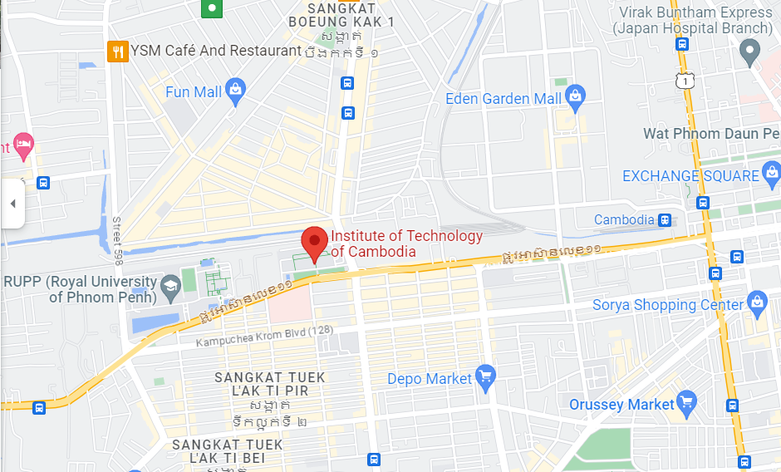Map:<https://www.google.com/maps/place/Institute+of+Technology+of+Cambodia/@11.5704027,104.8955108,17z/data=!3m1!4b1!4m6!3m5!1s0x3109517388680e15:0x63057e6682968f5!8m2!3d11.5703975!4d104.8980857!16zL20vMDZ5dmhz?entry=ttu>

Figure 2: Location ITC

### Hierarchy

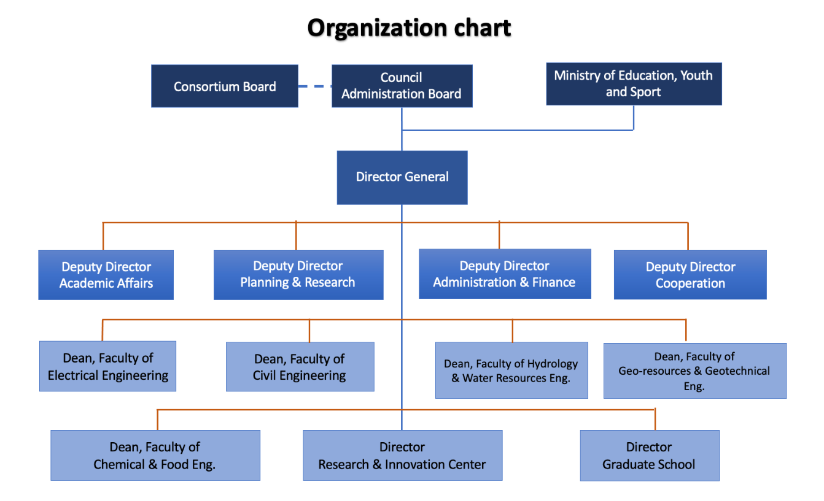

Figure 3: ITC Organization

# INTERNSHIP PROJECT PRESENTATION

## General Presentation of The Project

During my internship, I had the opportunity to work on a substantial project involving the development of a Securing Wireless Access Management System. The primary objective of this system was to facilitate seamless control over user access with restrictions in place. The tasks I undertook within this project included managing individual users and batches of users, storing their information in a database to grant access to the WiFi network, retrieving detailed user information, implementing Create, Read, Update, and Delete (CRUD) operations for user device, and configuring administrative login and logout functionalities, along with user account settings.

To realize this project, we harnessed the power of specific programming languages and frameworks. For the front-end, we utilized Vue 3, a JavaScript framework, to craft the user interface and enhance the user experience. On the backend, we leveraged Laravel 10, a PHP framework, to handle the server-side operations. My responsibilities in this project encompassed not only the design and development of the user interface but also the crucial task of seamlessly integrating the front-end and back-end components for both the website and the administrative dashboard.

## Problematic Overview

Access to the internet, primarily via Wi-Fi, is critical within an organization. However, the quality of this connection can be compromised when unauthorized users gain access by obtaining the Wi-Fi network name and password. In our specific case, students from various departments have managed to acquire the Wi-Fi network credentials, causing a decline in connection quality. This project addresses the challenge of unauthorized Wi-Fi usage within the Department of Information and Communications Engineering.

## Statement Of Problem

The primary issue at hand is the unauthorized use of the Wi-Fi network, resulting from students from different departments gaining access to the network by knowing the network name and password. This unauthorized usage not only degrades the connection quality but also poses security risks. To tackle this problem, we aim to implement a system that restricts Wi-Fi access to authorized users only, enhances connection speed, and simplifies administrative tasks related to user management.

## Objective

Within the Department of Information and Communication Engineering, a Wi-Fi network is available for students to facilitate their studies and research activities. However, a pressing issue has emerged, where students from other departments have become privy to the Wi-Fi network's username and password. This unauthorized access has resulted in a noticeable decline in the overall quality and performance of the Wi-Fi network.

To combat these challenges, the project aims to implement a solution. The primary goal is to identify and authenticate devices by capturing their MAC addresses. This will be achieved through user registration on a dedicated web application. The registered MAC addresses will be securely stored in a database. Furthermore, the project will utilize a radius server to automatically permit Wi-Fi access for devices with registered MAC addresses, thus mitigating the issue of unauthorized network usage.

The main objectives of this project are as follows:

* User Registration: Allow users to register up to five devices for Wi-Fi access through a web application.
* Automated Device Connection: Upon registration, enable registered devices to automatically connect to the Wi-Fi network.
* Unauthorized Use Prevention: Implement measures to prevent unauthorized users from accessing the Wi-Fi network.
* Administrative Control: Grant administrative control over user access to the Wi-Fi network, including the ability to manage registered devices.
* Device Usage Limitations: Implement restrictions on device usage to ensure fair and efficient Wi-Fi network utilization.

The overarching goal is to ensure that users within the Department of Information and Communications Engineering have access to high-quality Wi-Fi while mitigating unauthorized use, thereby enhancing network security and management.

## Development Life Cycle

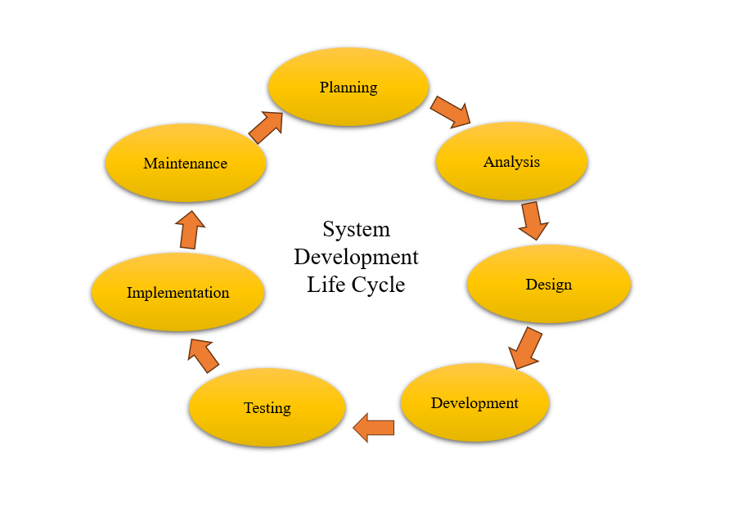

Figure 4: Web Development Life Cycle

There are different development strategies that are used in different way depending on the requirement of the project. For website or front-end team, we Vue JS as framework and GitHub to store the project and clone the project-to-project leader in the team.

It shows the approach of iterative toward project development. The first and foremost important thing we do at the beginning of the project is to study the requirement of the project. To understand the requirement more precisely, we arranged the meeting with our clients to collect most date as possible from them. Any doubts will be discussed later with our project manager in the meeting.

After fully understand the requirements, we start to discuss about how we are going to setup our local server and online server so that developer can test it at home.

The overall communication between team leader and developer, initially we need to choose the technology for using in this project. As we used Vue JS to build the UI of the website, we took some more time to review and study more details about the Vue JS and its framework. We then work rigorously on determining some optional functionalities we may need later during our development process. We also make sure that unit testing work appropriately.

During our implementation, we start to work on each function. When we finish one module, we do a manual unit testing. Unit testing is a software development process in which smallest testable module of an application, called units, are individually and independently test for proper operation. Should the test failed, we will go back to detailed design, and then debug our code again.

When unit testing is successfully completed, we move in to integration testing. Integration testing is software development process in which individually function of an application is tested together as a whole. It occurs after unit testing and will valid the operation of the system. However, in the case that it posed an error to the system, we would go back to high level design, detailed design to debug our process from the top to bottom, and redo it if necessary.

After we complete unit testing and integration testing, we make it available to deploy on server for company director to test our website as he is the one who will make the most requests to our website. If the result ok, the website completed; but if it’s not, we will start debugging the process from the top to implementation phase to find and fix the error. However, most of the time, we encounter the error during this phase, we only debug our code to fix the problem.

## Schedule

During the fourth year of their engineering program at the Department of Information and Communication Engineering (DICE) within the Institute of Technology of Cambodia (ITC), students are mandated to undergo an internship with a company. This internship serves as a critical prerequisite for their subsequent thesis defense. As part of this process, students are required to craft a comprehensive thesis report, elucidating the projects they undertook during their internship. The chosen project topic must be not only relevant but also defensible.

Interning with a company serves a multifaceted purpose. It enables students to acclimate to a genuine work environment, honing their soft skills, particularly in communication and collaboration with colleagues. This real-world experience allows them to gain a firsthand understanding of professional life.

Moreover, internships offer a valuable opportunity for students to forge strong relationships with the companies they work for. These connections can pave the way for potential reemployment during their fifth year or even provide a springboard for future career prospects. In essence, internships are a vital stepping stone towards bridging the gap between academic knowledge and practical, real-world application.

|  |  |  |  |  |  |  |  |  |
| --- | --- | --- | --- | --- | --- | --- | --- | --- |
| Tasks |  |  |  | **Weeks** |  |  |  |  |
|  | 1 | 2 | 3 | 4 | 5 | 6 | 7 | 8 |
| Learn Technology |  |  |  |  |  |  |  |  |
| Mockup UI |  |  |  |  |  |  |  |  |
| Design database |  |  |  |  |  |  |  |  |
| Analyze Requirement |  |  |  |  |  |  |  |  |
| Development |  |  |  |  |  |  |  |  |
| Testing |  |  |  |  |  |  |  |  |
| Report |  |  |  |  |  |  |  |  |

Table 1: Planning Project

As shown in the table above that showed the planning of my project during the internship period for the implementation of the Securing Wireless Access Management System, following the Agile methodology with the time table planning.

For the development, testing, and documentation as well I had to spend time 8 weeks to develop the project that we spend time from fist week to eight weeks. The work for each on the table planning is described below:

* Mockup UI: fist I have to discussion with my supervisor about UI of user and admin what we do, what we needed function and variable the on my project. After that I started to draw UI about user and admin.
* Learn new technology: During my internship, I got my project and I had to do research and learn about Vue JS Framework and Laravel like how to set up project, usage of this framework such as how to route each page. I did the research in document, watched many tutorials and offered some help from my team works. Therefore, I could catch up new technology fast and be able to learn and fix all my problems during the development process.
* Design database: I started researching about other website and YouTube templates prototyping in paper along with the database design.
* Analyze requirement: In the third week, I started to analysis about the project about the design and the main functionalities that are required by project manager. We have discussed about the requirement inside the meeting about what were the main requirements and optional requirements inside the project before starting it.
* Development:
* From third to eleventh week, I started implementing code using Vue JS and flow bite to build user interfaces. Before implementing, we have analyzed and divide the task plan in our project.
* After building UI of each page, I checked its responsiveness to make sure it looks well in each device.
* In case, there are new requirement or feedback from my project manager, I had to fix it, double check on my UI design and the flow again.
* About API, I used Laravel to build. I tested flow of API by using Postman to make sure it works well before connecting it with front- end.
* Testing: I did test part when I almost completed my user interfaces like responsiveness, accuracy routing to right destination page and checked whether its performance went smoothy when switching the pages while routing pages. If something went, I needed to implement again to make the website run well. Addition to that, I need to make sure it is connected well and go along well with flow of back- end.
* Report: I started to write the report to draft each step that I have done during development process and to make sure I would have enough time to correct my thesis report as well

## Detailed Project Description

### Scop of Study

When I have an internship web development, the scope of study during my web development internship:

* **Forntend:** Understanding of HTML, CSS, and JavaScript. Explore modern frameworks and libraries such as Vue.js. Learn about responsive design, accessibility, and optimizing web performance.opment internship
* **Backend:** Familiarize myself with server-side programming languages like PHP and frameworks Laravel. Study databases MySQL and learn about RESTful APIs. Gain experience in building and deploying web applications.
* **Full stack**: We combined font-end and back-end, How to connect API from back-end to font-end Vue.
* **UX and UI design:** web design, including layout, typography, color theory, and user experience (UX) design. Learn about design tools like Figma.
* **Version Control System**: using version control systems like Git. Learn how to collaborate with other developers using platforms like GitHub. Understand branching, merging, and resolving conflicts.

### Limitation of Study

During my web development internship, I may encounter certain limitations that can affect the scope of my study:

* **Frontend, Backend:** The projects assigned to you during your internship may have predefined requirements and objectives.
* **Time Constraints:** Internships usually have a fixed duration, which means I may have limited time to explore all aspects of web development thoroughly. It's important to prioritize and focus on specific areas that align with I learning goals.
* **Learning Curve:** Web development is a vast field with a steep learning curve, and it may not be possible to become an expert in all areas during an internship. It's important to manage your expectations and focus on building a strong foundation of knowledge and skills.

### Hardware And Operating System Used

* Hardeware:We used Laptop, Computer server and Moblie Phone
* Operating System: We used WindowOS and Ubuntu server

# ANALYSIS, CONCEPTION AND DESIGN

## Case Study ff Requirement

A case study of requirements for a web development internship involves understanding and documenting the specific goals and expectations of the intern and the organization providing the internship opportunity. It helps set clear expectations and defines the scope of work for the intern.

* **Frontend:** We have to learn about Language such as HTML, CSS, JavaScript and framework Vue JS to create frontend.
* **Backend:** Learn about language PHP and Laravel framework to create API (for data exchange between the frontend and backend systems), Database Management: Understand the fundamentals of database design and management, including SQL queries and ORM (Object-Relational Mapping) tools and Security and Authentication: Learn about implementing secure authentication and authorization mechanisms to protect data and user privacy.

### Function Requirement

The main functional requirements are those requirements that need to be designed and developed. It is very important to define because they must match the objective of the project.

#### Admin

The admin role holds the highest level of authority and is responsible for overseeing the overall management of the system. Admins have access to administrative functionalities, allowing them to manage user accounts, search user information, crud of user, show device user access the WIFI and catch mac address of user. They play a critical role in ensuring the system operates efficiently, making strategic decisions based on data insights provided by the system.

|  |  |  |
| --- | --- | --- |
|  | Admin Dashboard |  |
| Module | Feature | Sub Task |
| Authentication | Sign In | Login  Logout  Change password |
| Dashboard | Summary data | Image of WIFI  Number of users  Device detail of users |
| User List | All users | Create user  View user  Update user  Delete  Mange device on user  Search Information of user |
| Import User Data | Import excel user | Manage user |

Table 2: Admin Dashboard of Project

* Login: for admin login to access the dashboard by username and password.
* Manage user: for manage user can use and access to the WiFi, we need create account for user have username userId Department generation password and role id.
* Import excel data: for import data by file excel is this way can create many users on the time, row on file excel is variable of user have username userId Department generation password and role id and column are number of users.
* Search information user: for this point if you want to know about information a user you can input username of user or userId of user, will be show information user you input.
* Crud of user:

Crud (create, read or view, update, delete), operations for user management is a common practice in software development. Here are some reasons why CRUD operations are useful when managing users:

* Create: The "Create" operation allows you to add new users to the system. When managing users, you need the ability to create new accounts and store their information in a database or other data storage mechanism.
* Read Or View: The "Read" operation enables you to retrieve user information from the system. It allows you to view user details, such as their username, email, role, or any other relevant information associated with each user. Reading user data is necessary for displaying user profiles, generating reports, or performing various tasks related to user management.
* Update: The "Update" operation allows you to modify user details. User information can change over time, such as updating their email address, changing their password, or modifying their profile information. The ability to update user data ensures that the system stays up-to-date with the latest information.
* Delete: The "Delete" operation enables you to remove users from the system. There may be scenarios where you need to deactivate or delete a user account, either due to inactivity, policy violations, or other reasons. The delete operation allows you to remove the user's data and ensure it is no longer accessible within the system.

#### User

They are many users’ accesses to Securing Wireless Access Management System. The user role focuses on providing a user-friendly interface. The role of user after login to be access the WIFI user can view information, change password, register device, delete device and device detail.

|  |  |  |
| --- | --- | --- |
|  | User Dashboard |  |
| Module | Feature | Sub Task |
| Authentication | Sign In | Login  Logout  Change password |
| Dashboard | Summary data | Account Information |
| List of users | Manage device | View information  Register device  Delete device  Device detail |

Table 3: User Dashboard of Project

* Login: use login to access the WiFi by username and password.
* Change password: after login user can change new password if user want to change.
* List of users: after user login and change password already user can go to dashboard of user, dashboard user can view of all your information.

### Non-functional Requirement

There are optional requirements of developing Securing Wireless Access Management System:

* Attractive but simple design: Interface needs to look attractive but simply to use, understandable and not complicated.
* Responsiveness of user: the size of the website has to be flexible to any devices
* Performance: speed of moving each pages need to be fast
* Maintenance: website need to be well organized so that data that get from API could be displayed in right place, right category and easy to debug error and make correction

## Constrained System

### Constrained System

Constrained Techniques in the context of a web development internship typically refers to working within certain limitations or constraints when developing web applications or websites. These constraints can arise from various factors, and as an intern, it's essential to understand and adapt to them. Here are some common constraints I might encounter during a web development internship:

* Technology Stack: The company may have a specific set of technologies or programming languages they prefer to use. As an intern, I need to learn and work with these technologies even if I have experience with others.
* Accessibility: Ensuring that web applications are accessible to all users, including those with disabilities, can be a constraint. I need to follow accessibility standards and guidelines.
* Team Collaboration: Working within a team can also bring constraints in terms of communication, collaboration tools, and version control systems.

### Constrained Time

Constrained time in the context of a web development internship refers to the limitations or pressures related to time that you might experience while working on projects or tasks within the company. Time constraints are common in professional settings, and they can impact how you plan, execute, and deliver your work. Here are some aspects of constrained time you might encounter during a web development internship:

* Project Deadlines: web development projects have specific deadlines that must be met. I'll need to manage my time effectively to ensure that I can complete tasks and deliverables on schedule.
* Meetings and Collaborative Work: Meetings and collaborative sessions with team members or stakeholders can consume a significant portion of my time. Balancing these activities with actual development work requires effective time management.
* Code Reviews and Feedback: The time allocated for code reviews and incorporating feedback from senior developers or team leads is another aspect where time constraints may apply.

### Use Case Diagram

The use case diagram is defined to prove the demanding features in our application. Each use box expresses the import module that will be implemented and that contains the other features in it.

In the diagram, there is the keyword "include", that is to say before accessing our website to experience more functionalities, it is necessary that this actor authenticates his identification first. However, the keyword “extend” is to say that you if you not yet login in. If you log in successfully, user can access to homepage and manage information for user.

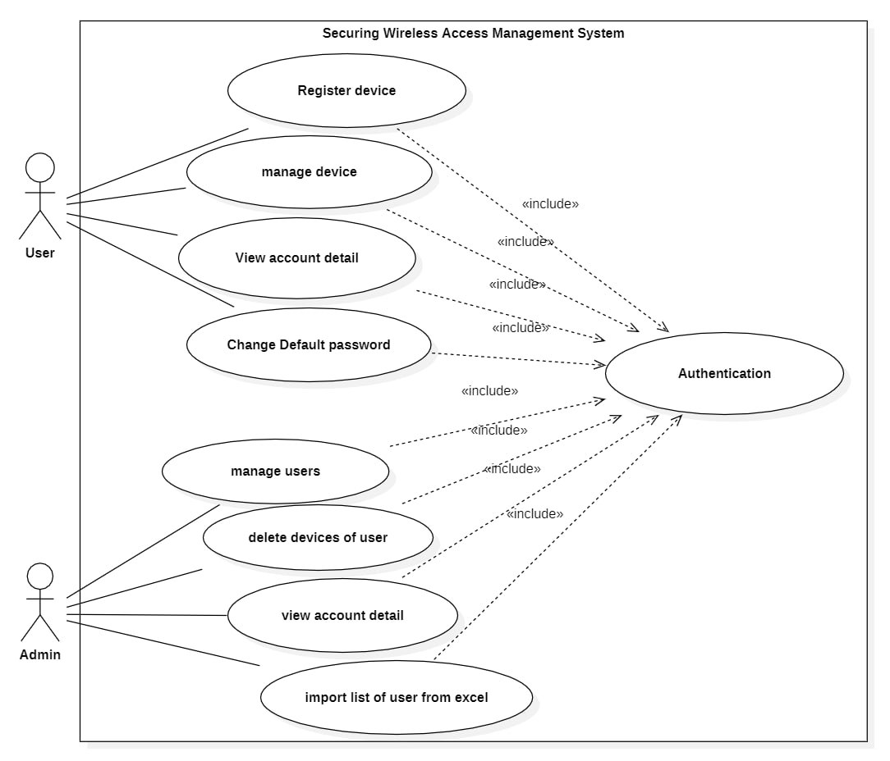

Figure 5: Use Case diagram

The use case above describes some functionality that the user and admin can interact with the web application.

**User can after logging in:**

* User can register device to Wi-Fi limited 5 devices.
* User can view their information and edit their information.

**Admin can after logging in:**

* Can be manage users
* Can be manage device users
* Can be create account user one by one or many users by excel file
* Can be search information user
* Can be crud operation on users

### Activity Diagram

This is some activities of admin and user such as:

* Activity diagram of admin login and manage user

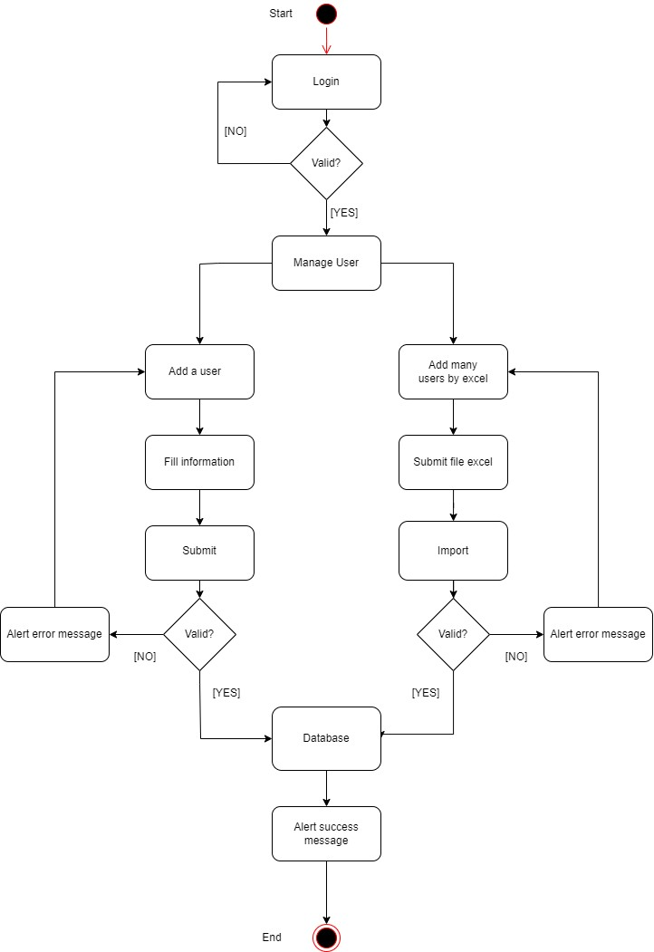

Figure 6: Admin Activity Diagram

* Fist admin have to login to be access to admin dashboard.
* Second if admin login success goes to dashboard to manage account for users to access to WiFi.
* Third for manage users have to option:
* Add one by one user, we have filled all information of user on form button add user and then click submit. If you not fill wrong format, you cannot submit add user its alert message tells you must be filling information of user.
* Add many users, add by file excel. When you add is user have duplicate, have done on database alert message and show userId that duplicate. One more when manage user on file excel row have variable of user such as username, userId, password, generation, department and column number of user have to add.
* After manage user successful, data of user in have to store on DB.
* 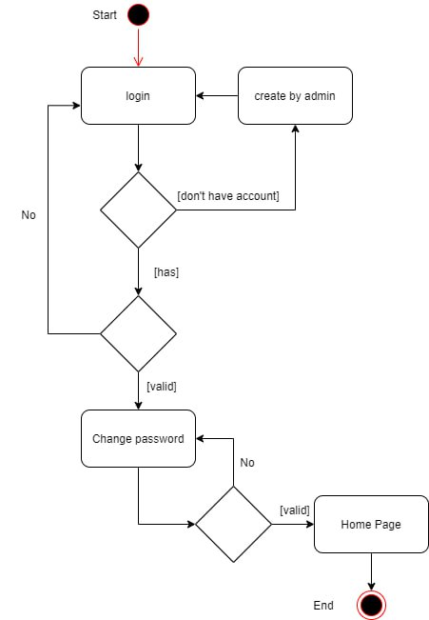Activity Diagram of user login

Figure 7: user activity diagram

* For Login users need to have account which create by admin.
* User account by default username and password are the same.
* After checking valid with database and check username and password are the same it will go to change password page. If username and password are not the same it will go to homepage and they can register device.
* If, user has to change password already when they login in the second time they will redirect to homepage

### Conception of Database

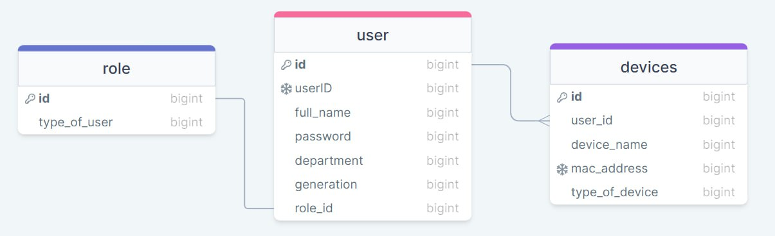

Figure 8: Database design

Conception database of my project for account user manage by admin not register.

* After have account user can login to be access WiFi, if username or password has on DB it allows user to user and not have on DB cannot access to WiFi.
* On username or password of user can access to WiFi has limited, it can joint maximum 5 device.
* When you user can access to WiFi admin catch mac address of user and device to store in DB.

# CHOICE OF TECHNOLOGY AND DESIGN

## Technology Choice

### Programming Language

For develop this project we used some language such as HTML CSS JS PHP:

**HTML** stands for Hypertext Markup Language. It is the standard markup language used for creating and structuring web pages. HTML uses a set of markup tags or elements to describe the structure and content of a web document.



Figure 9: HTML Logo

**CSS** is standing Cascading Style Sheet language used for style web page and describing the look and formatting of a document written in HTML. CSS separates the presentation of a document from its structure, allowing web designers to control the visual appearance of web pages.



Figure 10: CSS Logo

**JS** stands for JavaScript. It is a high-level programming language primarily used for adding interactivity and dynamic behavior to web pages. JavaScript is a versatile language that runs in web browsers, allowing developers to create interactive elements, handle events, manipulate the document object model (DOM), and communicate with servers.



Figure 11: JavaScript Logo

**PHP** refers to a server-side scripting language that is commonly used to build the backend components of web applications. Backend development focuses on the server-side logic and functionality that powers a website or web application, handling tasks such as data processing, database interactions, and server-side operations.



Figure 12: PHP Logo

### Framework Technology

We are used some framework to develop my project such as:

**Vue** is a JavaScript framework for building user interfaces. It builds on top of standard HTML, CSS, and JavaScript and provides a declarative and component-based programming model that helps you efficiently develop user interfaces, be they simple or complex.



Figure 13: VUE Logo

**Laravel** is a popular open-source PHP framework used for web application development. It was created by Taylor Otwell and released in 2011. Laravel follows the Model-View-Controller (MVC) architectural pattern and provides a robust set of tools and features that simplify the development process.



Figure 14: Laravel Logo

### Library

We are used some library for support and help design front-end such as:

**Tailwind CSS** is a popular utility-first CSS framework that provides a set of pre-defined utility classes to rapidly build user interfaces. It was created by Adam Wathan, Jonathan Reinink, David Hemphill, and Steve Schoger. Unlike traditional CSS frameworks that focus on providing pre-designed components, Tailwind CSS focuses on providing a comprehensive set of low-level utility classes that can be combined to create custom designs.



Figure 15: Tailwind CSS Logo

**Flowbite** is a library of components built on top of the utility-classes from Tailwind CSS and it also includes a JavaScript file that makes interactive elements works, such as modals, dropdowns, and more. Learn how to get started by following this quick start guide.



Figure 16: Flowbite Logo

### Tool

We are used many tools to create this project such as:

Short for Visual Studio Code, we used for write code this project and it is a free and open-source code editor developed by Microsoft. It has gained significant popularity among developers due to its extensive features, cross-platform compatibility, and a large ecosystem of extensions.



Figure 17: VS Code Logo

**Git Bash** is used for run command line to store code on GitHub and it is highly popular among developers because it allows them to use Git and execute various Git commands from the command line in a familiar Unix-like environment, even on Windows operating systems. It provides a way for Windows users to access the full power of Git and utilize the same command-line interface (CLI) and workflows available on Unix-based systems.



Figure 18: GitBash Logo

**GitHub** used for store code and it is a web-based platform that provides hosting services for version control using Git. It offers a centralized location for developers to collaborate, share, and manage their software projects. GitHub combines code hosting, version control, issue tracking, and collaboration features, making it a popular choice for individual developers and teams. GitHub essentials like repositories, branches, commits and pull request.



Figure 19: GitHub Logo

**Postman** is a popular collaboration platform and API development tool used by developers to design, test, and document APIs (Application Programming Interfaces). It provides a user-friendly interface that simplifies the process of working with APIs and enhances the efficiency of API-related tasks.



Figure 20: Postman Logo

**Figma** is used for draw UI on my project and a cloud-based design and prototyping tool used for creating user interfaces (UI), user experience (UX) designs, and interactive prototypes. It provides a collaborative environment for designers, developers, and stakeholders to work together on design projects in real-time.



Figure 21: Figma Logo

**Drawsql** is used for draw database design and it is a web-based tool that helps developers and database administrators (DBAs) visualize, document, and collaborate on database schemas. It allows users to create entity-relationship diagrams (ERDs) by visually designing the structure of their database tables and their relationships.

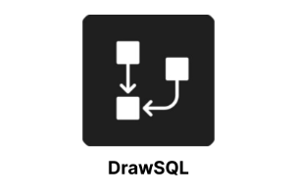

Figure 22: DrawSQL Logo

**StarUML** used for draw activities on project on admin, user and it is a software engineering tool for system modeling using the Unified modeling Language as well as Systems Modeling Language and classical modeling notations.



Figure 23: StarUML Logo

**MySQL** is an open-source relational database management system (RDBMS) that is widely used for managing structured data. Unlike NoSQL databases, MySQL follows a traditional relational model and is suitable for handling structured data with well-defined schemas. It allows users to store, retrieve, and manipulate information in a tabular format. MySQL is commonly utilized for various applications and can efficiently handle high-volume data storage, facilitating organizations in storing and managing large amounts of data while ensuring optimal performance.



Figure 24: MySQL Logo

## System Design

System architecture is the concept model that defined the structure, behavior and other views of a system. There are two components is physical and logical architecture and following describes the detail of process about those architecture in our website.

### Physical Architecture

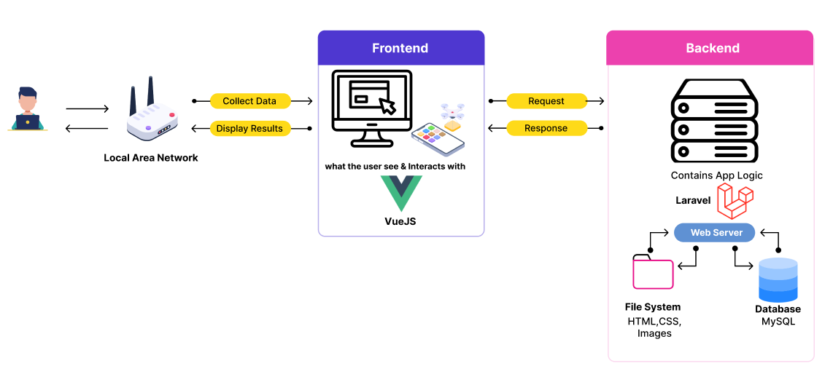Physical architecture describes about the external architecture such as devices used in our website in order to get it up and running.

Figure 25: Physical Architecture

The physical architecture of a system plays a crucial role in ensuring the reliable and efficient functioning of the software application. It defines the distribution and arrangement of the system's components, including the client web browser, web server, database server, and file system, among others. The physical architecture is essential because it addresses the practical aspects of deploying and running the system in a real-world environment.

* + **Client Web Browser:** The client web browser is the user's interface to interact with the Securing Wireless Access Management System. It can be any modern web browser such as Chrome, Firefox, Safari, or Edge. The web browser renders the user interface components, handles user inputs, and communicates with the web server to request and receive data.
  + **Web Server:** The web server acts as the central hub for processing client requests and serving responses. It receives requests from the client web browser and handles them by retrieving or updating data from the database server. It also performs business logic and applies any necessary processing before sending the response back to the client. The web server utilizes technologies such as Laravel and Vue JS to handle the server-side processing and generate dynamic web pages.
  + **Database Server:** The database server stores and manages the system's data. It uses a database management system (DBMS) such as MySQL to store structured data related to menus, user information, reservations, and other entities. The database server ensures data integrity, provides efficient data retrieval and storage, and supports query operations.

### Logical Architecture

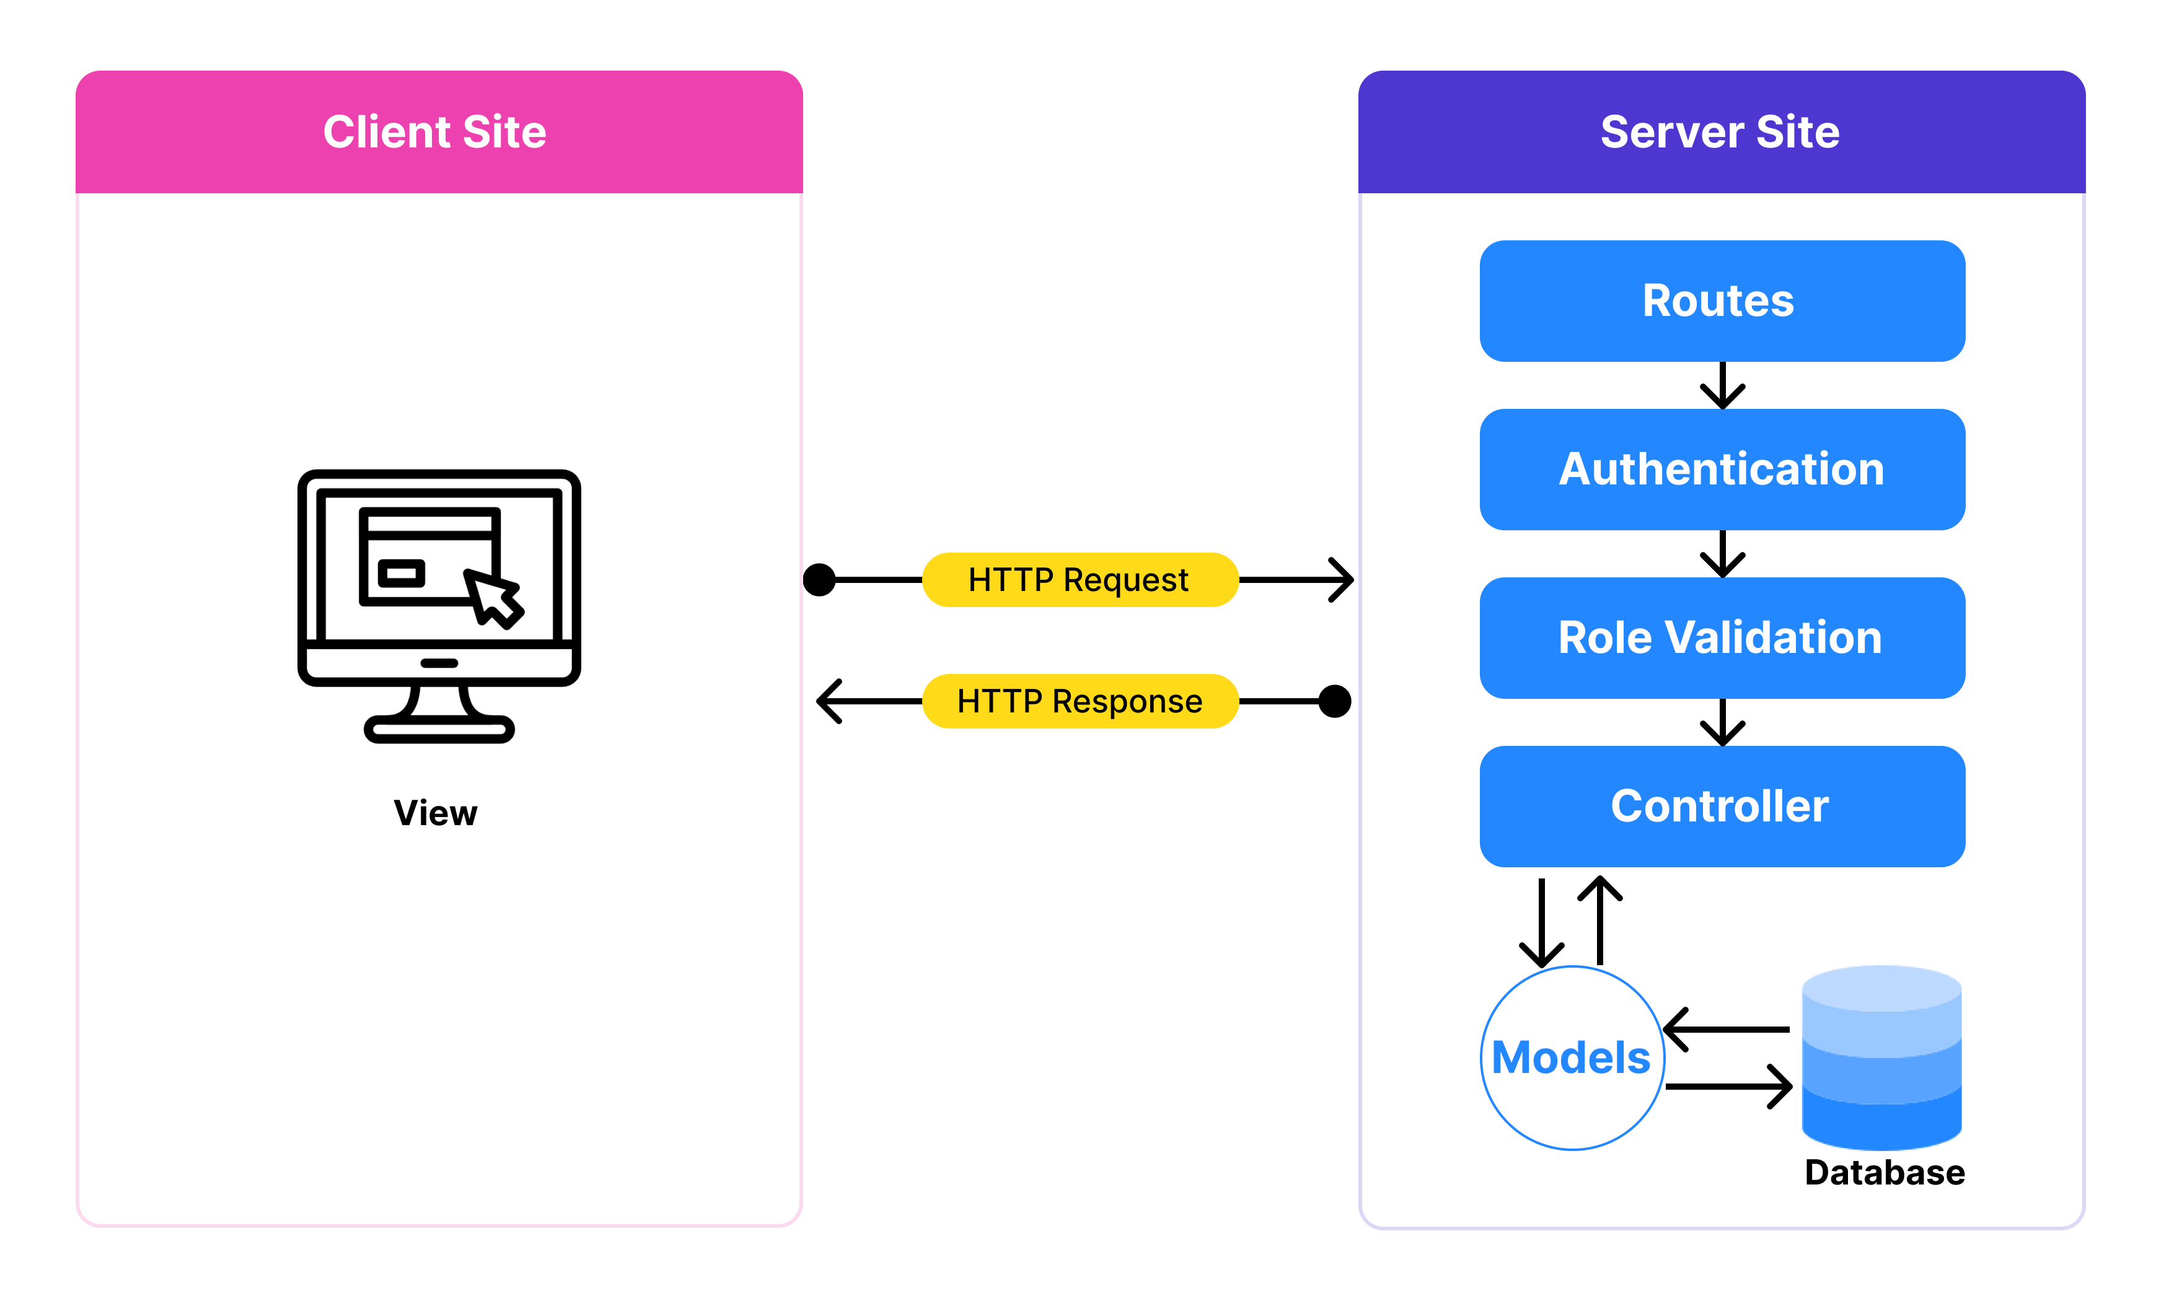

Figure 26: Logical Architecture

* **Client:** The client component represents the user interface through which users interact with the system. It can be a web browser or any other platform that communicates with the backend components. The client sends requests to the server, receives responses, and displays the relevant information to the users.
* **Authentication:** The authentication component handles user authentication and identity verification. It ensures that users are who they claim to be before granting access to the system. It manages user login functionality. This component interacts with the user's credentials, validates them, and generates authentication tokens or sessions to maintain user sessions.
* **Role Validation:** The role validation component ensures that users possess the required roles or permissions to perform certain actions. It checks if the user's role allows them to access or modify specific resources. It collaborates with the authorization component to enforce role-based access control and restrict unauthorized actions.
* **Controller:** The controller component acts as an intermediary between the client and the backend logic. It receives requests from the client, processes them, and coordinates the appropriate actions within the system. It handles the business logic, validates inputs, invokes necessary operations on the models, and prepares responses to be sent back to the client.
* **Model:** The model component represents the data entities and the business logic associated with them. It encapsulates the structure, behavior, and relationships of the system's data. The model interacts with the database to retrieve, manipulate, and store data. It may also include validation rules and data processing methods.

### Sequential Diagram

* **Admin manage user:**

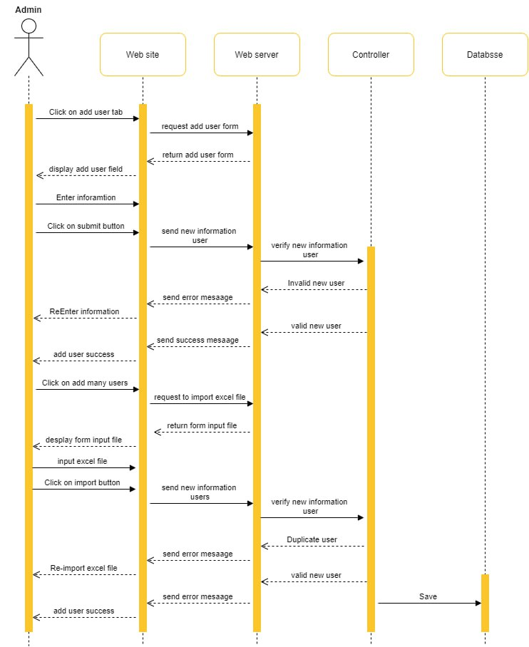

Figure 27: Admin Sequential Diagram

* Admin after login success, admin click button add user and request to webserver to create user. Next web server returned form to fill information of user. After fill information check format if true in save on database and alert message create successful.
* Admin can add many users by file excel. Controller will data in this excel file if it is not duplicated it will save into database and send successfully message to client. If in excel file has data that duplicate with data in database it will reject and send error messages to client.
* 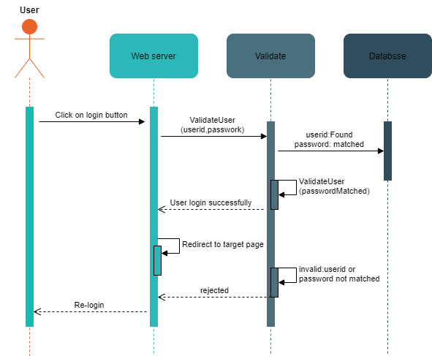**User login:**

Figure 28: Sequential user login diagram

* User request to server for login page and fill username and password to login.
* Validation will check user id in database if it is found and check password if it is matched its return success and will redirect to target page for user.
* If user id of user not or password is not match the validation will rejected.
* Rejection, its return error message to user and user need to login again.
* Register device of user:

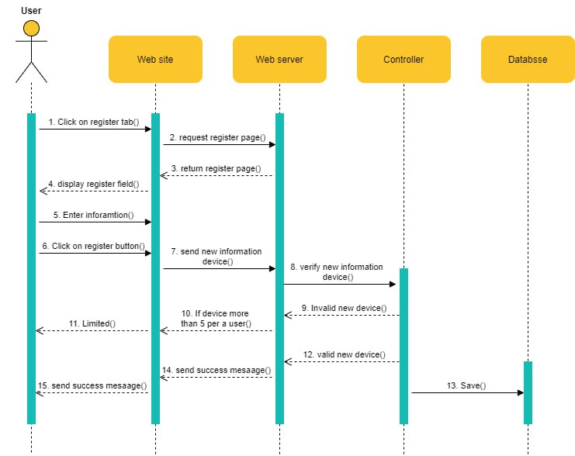

Figure 29: Sequential Register device of user

* After login success, User request to register their to server. The server return register to user.
* User need to fill some information and click register button. It will send this information to the server.
* Controller will check these information, one specific information is mac address of user’s device. If it is not existed and it does not have more than 5 it will store into database. And send messages successfully to user.
* If controller check the mac address of client it already existed or has more than 5 it will reject and send error messages to user.

# PROJECTS IMPLEMENTATION

## Project Setup

The project setup for the Securing Wireless Access Management System involves several steps to prepare the development environment and establish the necessary infrastructure. Firstly, the front-end of the system is built using Vue JS, a popular JavaScript framework.

On the other hand, the back-end of the system is developed using Laravel, a PHP framework known for its elegance and simplicity. The developer sets up the Laravel development environment by installing PHP, Composer, and Laravel CLI.

* Prerequisites
* **VS Code**: Vetur Extension
* **Terminal:** VS Code’s integrate terminal
* **Laravel**: Version 10
* **Vue:** Version 3
* Front-end setup project

**Step 1:** create a folder on the desktop and navigate to the folder through terminal

**Step 2:** Run command line on the terminal

***npm create vue@latest***

**Step 3:** After that we have select some option in terminal section to our project and then run command line on the terminal

* ***cd wifi-management-system***
* ***npm install***

**Step 4:** Now navigate to our app folder through command line. Following this picture show the project structure

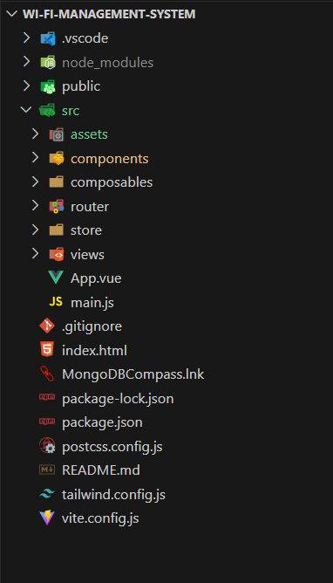

Figure 30: Project Structure Vue

Project structure specifications:

* **Src folder**: This folder contains the source code of your Vue 3 project. It includes the following files and folders:
* **Assets folder**: This folder is used to store static assets such as images, icons, and CSS files that are imported and used in your components.
* **Components folder**: This folder is used to store reusable components that are used throughout your application.
* **Router folder**: This folder contains the configuration and routes for your application's routing system if you choose to use Vue Router.
* **Store folder**: This folder contains the store modules and configuration files for Vuex, which is Vue's state management library.
* **Views**: used to store the components that represent the different views or pages of your application. It's a way to organize and separate the components that are responsible for rendering specific pages or sections of your application.
* **App.vue**: This is the root component of your application. It usually consists of the template, script, and style sections.
* **Main.js:** This is the main entry file of your Vue application. It initializes the Vue instance and mounts the root component.
* **Package-lock.json**: File is automatically generated when you use npm (Node Package Manager) to install packages in your Vue 3 project. It serves as a record of the exact versions of the installed dependencies and their sub-dependencies.
* **Package.json**: This file holds metadata about your project and lists the project's dependencies. It also includes scripts for running development and build processes.
* **Tailwind.config.js**: Is used to customize the configuration of the Tailwind CSS framework. It allows you to modify and extend the default configuration to suit your specific design needs.
* **Vite.config.js**: Is used to configure and customize the build tooling provided by Vite. It allows you to modify various aspects of your development and production builds.

**Step 5**: Run our project by using command line ***npm run dev***

After run command line on your terminal, you will be seeing URL below you can click URL to access web browser ( <http://127.0.0.1:5173> ).

**Step 6**: Install library of tailwind CSS on Vue JS we are used some command line on the terminal project:

**Command line install Tailwind CSS**

* ***npm install -D tailwindcss***
* ***npx tailwindcss init***

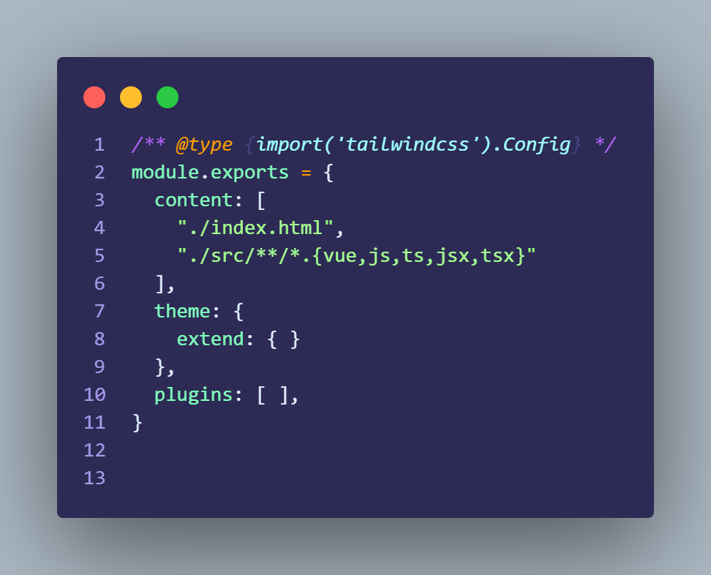**Configure the template our project**

Figure 31: Configure Tailwind on Vue

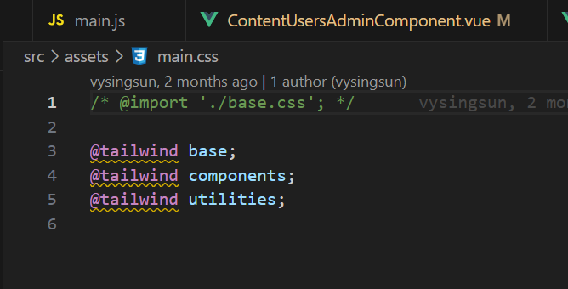**Add the Tailwind directives to file CSS**

Figure 32: Add Tailwind to file CSS

**Step 7**: Install library of flowbite on front-end project

**Using Command line:**

* ***npm install flowbite***

**Require flowbite as a plugin file tailwind.config.js**

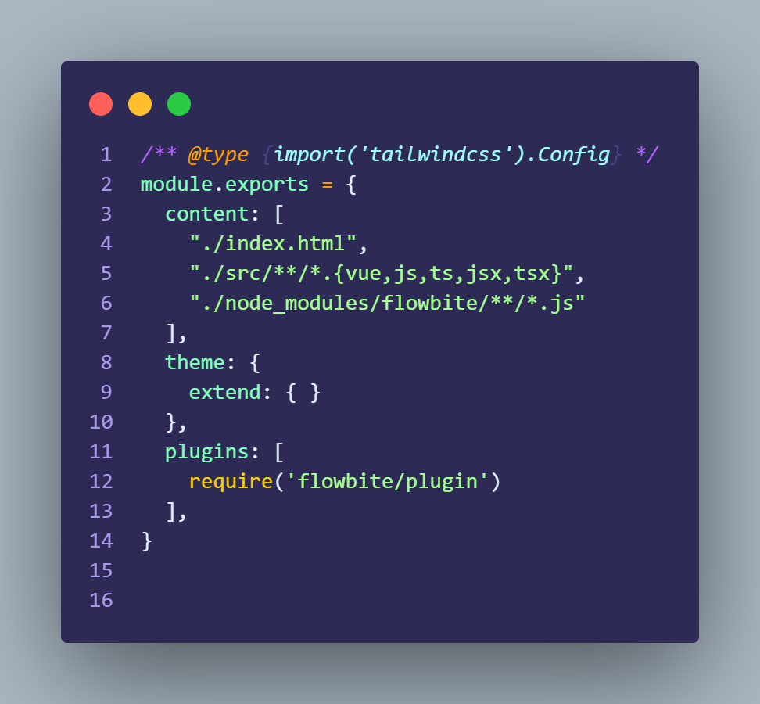

Figure 33: Require flowbite Plugin on file tailwind.config.js

**Init functions on script file**

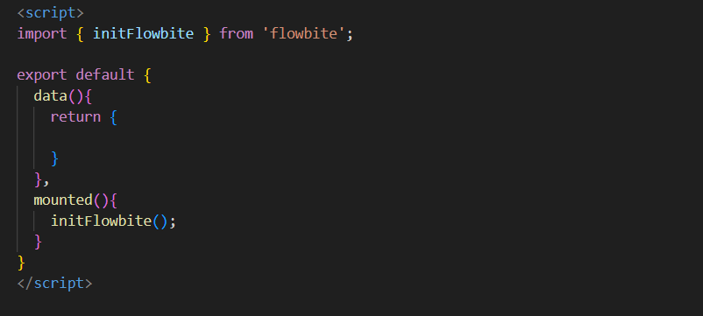

Figure 34: Init function on script file

* **Back-end setup project**

**Step 1:** create a folder on the desktop and navigate to the folder through terminal

**Step 2:** Run command line on the terminal

***composer create-project laravel/laravel backend***

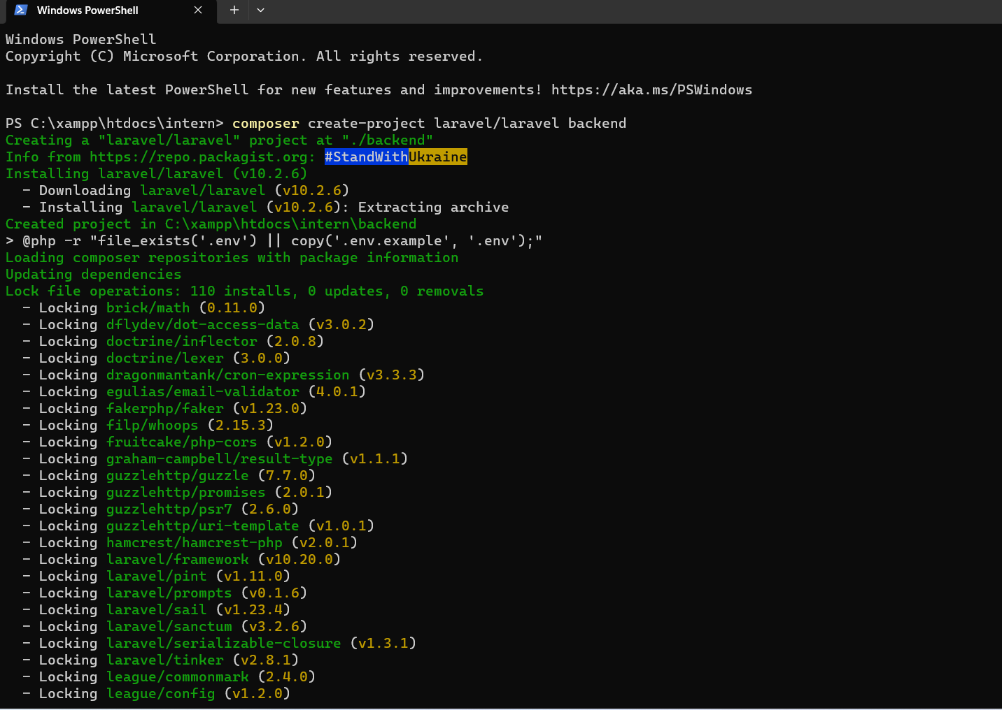**Step 3:** After that we have select some option in terminal section to our project

Figure 35: Laravel Setup Project

**Step 4**: Now navigate to our app folder through command line. Following this picture show the project structure.

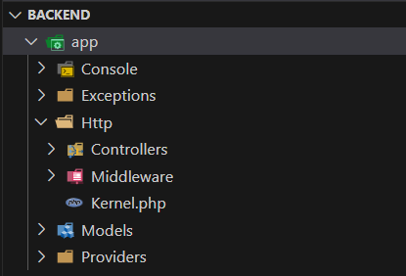

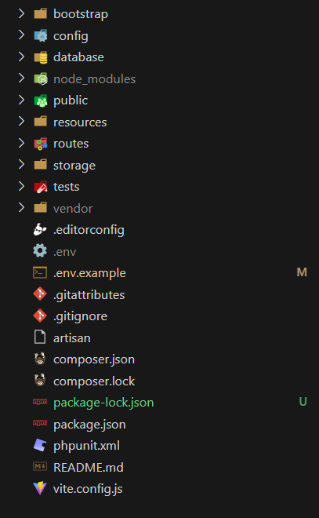

Figure 36: Laravel Project Structure

* **App:** The app folder is the heart of my Laravel application. It contains essential files and folders, such as controllers, models, middleware, and service providers.
* **Controller:** The Controllers folder contains the controller classes of my application. Controllers handle the incoming requests, process the data, and return the appropriate response.
* **Models:** The Models folder contains the model classes of my application. Models represent the data entities in your system and are responsible for interacting with the database.
* **Bootstrap:** The bootstrap folder contains files responsible for bootstrapping my Laravel application.
* **Config:** The config folder holds various configuration files for my application.
* **Database:** The database folder is used for database-related tasks. It includes migration files for defining database structure and seeders for populating the database with initial data.
* **Public:** The public folder contains the entry point for my application, which is the index.php file. It also stores publicly accessible assets such as CSS, JavaScript, and image files.
* **Resources:** The resources folder holds non-PHP resources like views, language files, and frontend assets. It includes the views folder, where I can define the user interface using Blade templates.
* **Routes:** The routes folder contains route definition files. Here, I can define your application's URL endpoints and associate them with corresponding controllers and actions.
* **Storage:** The storage folder stores various files generated by my application.
* **tests:** The tests folder holds test files for unit testing your application. It includes example test cases and can be expanded with additional tests as my application grows.

## Configuration

For fetch API from back-end Laravel to Vue JS we using library of JavaScript axios. We can use the command line ***npm install axios*** on Vue JS.

* Axios is a popular JavaScript library used for making HTTP requests from a web browser. It provides an easy-to-use API that allows you to send asynchronous HTTP requests to a server and handle the responses.

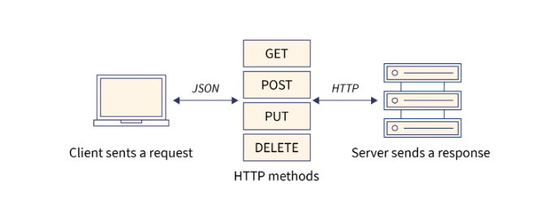

Figure 37: Axios Methods

Axios supports various features, including:

* Making HTTP requests: Axios supports all the common HTTP methods like GET, POST, PUT, DELETE, etc. You can use these methods to interact with your server-side API endpoints.
* Promise-based: Axios is built on top of JavaScript promises, which allows you to handle asynchronous operations more easily. It returns a promise that resolves with the response data or rejects with an error.
* Interceptors: Axios provides interceptors that allow you to intercept and modify HTTP requests and responses globally. You can use interceptors for tasks like adding headers, handling errors, or transforming data.
* Request and response configuration: Axios allows you to configure various options for your requests and responses, such as headers, timeout, response types, and more.
* Canceling requests: Axios allows you to cancel requests using cancel tokens. This can be useful when you want to cancel ongoing requests if, for example, a user navigates away from a page.

Make API requests from Vue components:

* Import the axios library (or any other HTTP client) in your Vue components: import axios from 'axios'.
* Use the imported axios library to make HTTP requests to your Laravel API endpoints.

Below is example of api request syntax:

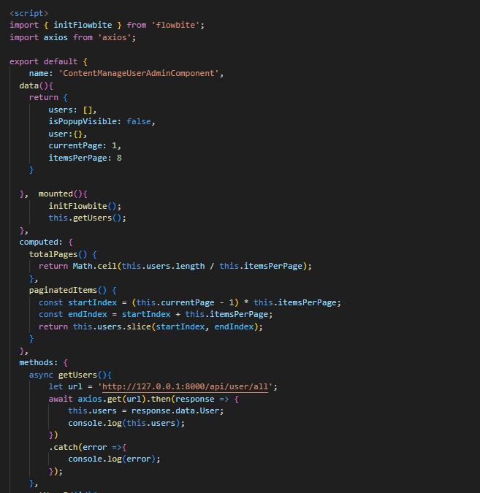

Figure 38: Fetch API Backend on Vue

## Implementation

To implement front-end or user interface according to all required functions is not an easy task to do. Some flows are easy to develop but some flows are difficult to develop and take some time to deal with. However, it was quite challenging to solve all those problems and gain new experience in web development. Below are some functions that I have overcome with and some descriptions about them.

### Authentication activity of Admin Login

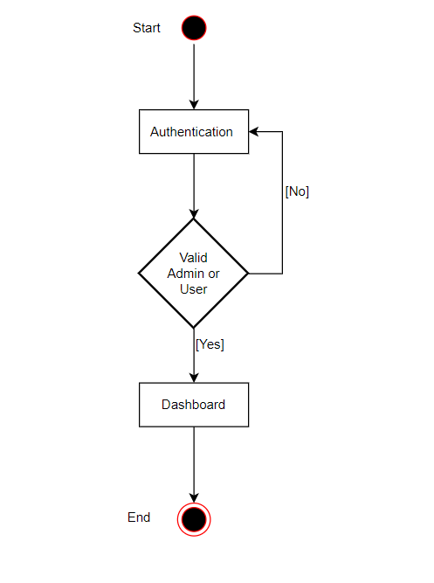

Figure 39: Authentication activity of Admin

* For admin authentication when login to access the management dashboard.
* API will send the request to database to check whether user is existed and the provided userId and password are valid or not, especially their role as admin.
* If user is valid as an admin, page will be redirect to management dashboard.
* If userId and password are not valid, user has to stay in the login page and repeat their action of login again.

### Admin Dashboard activity diagram

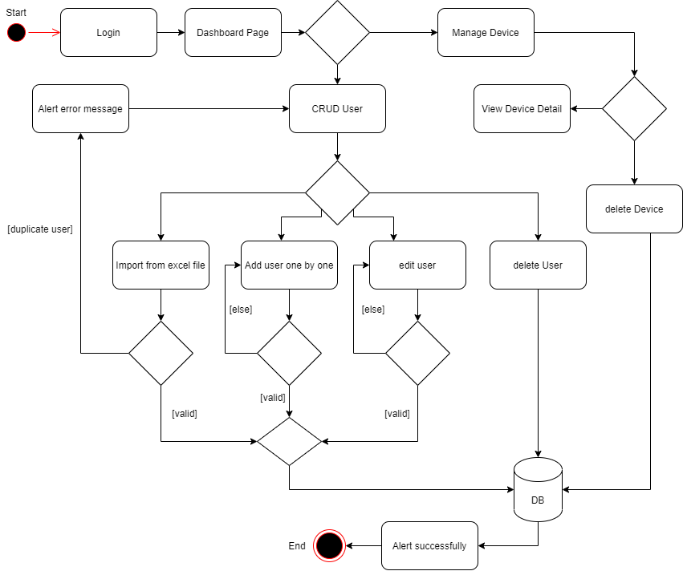

Figure 40:Admin Dashboard activity

This is flow of admin dashboard on my project such as:

* Fist admin have to login to access to dashboard.
* After login success admin can manage user, manage device of user, crud operation on users and can delete device of user.
* For manage user can add a user and many users.

### Activity diagram upload data by file excel

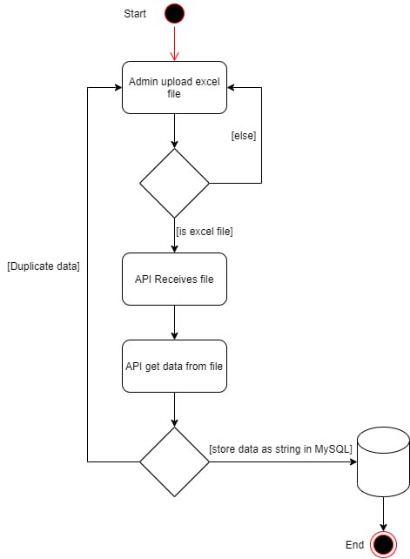

Figure 41: Activity of upload data by file excel

* Fist choose button to upload on file excel to process to back-end to read data on file.
* When manage user if have data duplicate APIs send request and alert message, if not duplicate data have to store in DB.

### User Dashboard activity

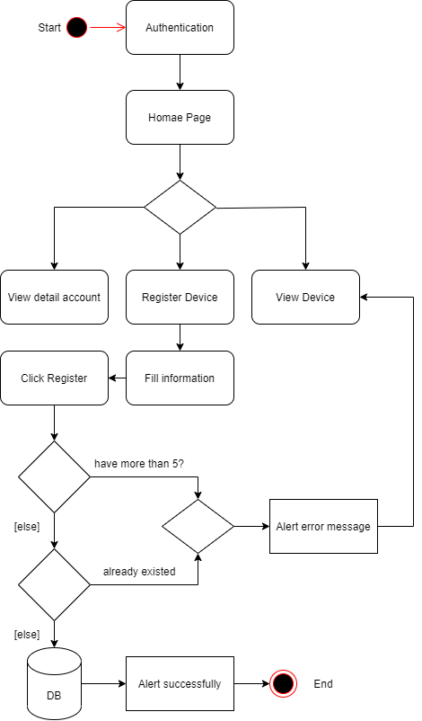

Figure 42: Activity of user dashboard

* This flow show how I manage all flow of pages display in the web application.
* For homepage, user can see their information, change password, register device delete device and updated device.
* In registration of user’ device the web application will learn mac address of user device and store into database. And then administrator get those mac address to check with radius server if valid it will allow user to use the Wi-Fi.
* After registration successfully, user can user the Wi-Fi.

## Problem and solution

During the two months of my internship, I encountered some challenges in my project’s development. The primary issues stemmed from my limited experience with the Laravel and Vue technologies. Specifically, I faced difficulty in comprehending hoe to create APIs on the Laravel backend and establish a connection between these APIs and the Vue frontend. These were the key hurdles I encountered during the internship.

# CONCLUSION

## Summary

In summary and conclusion, for my internship develop on system of Securing Wireless Access Management System was a comprehensive project. The system was designed to easy control of user has limited. For task of this project such as manage user one by one or many users to store in database to access the WiFi, search information detail of user, crud of user, login and log out admin, setting account user. We used some language such as to build code, font-end use Vue 3 is framework of JS and Laravel 10 is framework of PHP for back-end.

### Complete Work

In summary, my internship project involved the development of a comprehensive WiFi management system. The primary goal of this system was to provide easy control over users with limitations. The key tasks within this project included managing individual users, storing their information in a database to grant WiFi access, retrieving detailed user information, implementing Create, Read, Update, Delete (CRUD) operations for user data, and incorporating admin login and logout functionality, as well as user account settings.

To realize this project, we utilized specific programming languages and frameworks. Vue 3, a JavaScript framework, was employed for the front-end to build the user interface, while Laravel 10, a PHP framework, was used for the back-end to handle server-side operations. This combination of technologies enabled the successful execution of the project.

Table 4: Table of Tasks Admin

|  |  |  |
| --- | --- | --- |
|  | Role of admin |  |
| Modules | Functionalities | Status |
| Authentication | Login | Completed |
|  | Logged admin information | Completed |
|  | Add user | Completed |
|  | View information user | Completed |
|  | Update information user | Completed |
| Menu | Delete user | Completed |
|  | Import data by file excel | Completed |
|  | Search user by username | Completed |
|  | Show device user access WIFI | Completed |
|  | Catch mac address user | Completed |

Table 5: Table of Tasks User

|  |  |  |
| --- | --- | --- |
|  | Role of user |  |
| Modules | Functionalities | Status |
|  | Login | Completed |
|  | Change password | Completed |
| Authentication | Logged user information | Completed |
|  | View list information of user | Completed |
|  | Device detail | Completed |
| Menu | Delete device | Completed |
|  | Register device | Completed |

### Incomplete Work

On my project, we have many tasks completed but we have some tasks no completed. There are some points uncomplete in have to improve such as:

* + Responsive is not better
  + Forgot password user and admin
  + Integrate with network on use radius server
  + Hosting is not already

## Strong Point

After development on this project, we have found some of the strong points in our website as the following:

* Its good user interface and user experience
* Easy control of the system
* Easy Manage of user
* For user access the WiFi has limited
* Can control data of user
* For admin know information and mac address when user access to WiFi

## Week Point

Although, my website has many features for users to manipulate the data and has many strong points since we have spent only a short period to build, there are many weak points to improve as well such as:

* This table shows how many tasks each role (admin, user) has completed and how many are still pending in the WIFI management system. The table helps to monitor the progress and performance of each role in managing the WIFI network.
* There are many functions and features that needed to add is better.

## Experiences

Through this internship, I have learned a lot in terms of both technical and soft skills from workplace environment.

* Firstly, I have acquired hard skills such as:
* Learning and practicing new technologies in real project with Vue JS, Laravel and MySQL as technologies in the process of full stack development.
* Researching about using new technologies, debugging and finding solution to the problems related to coding and implementing.
* Full stack development.
* Database management.
* Secondly, I have developed soft skills such as:
* Asking for help when needed with my colleagues on my team.
* Communicate with the team’s project
* Solving difficulties in development process by taking and giving suggestions during weekly meetings.
* Dealing with problems with multiple solution and working as a team in a real work environment.

Therefore, I have gained valuable experience and knowledge from this internship that will help me in my future career. In conclusion, I am grateful for this opportunity and I appreciate the guidance and support from my mentors and colleagues.

## Difficulties

For my internship during two months at ITC, I have some problem to do my project such as:

* We know that every year for internship has three months, but this year we have two months so I have short time to do my project.
* I don’t know clear about fetch data APIs from back-end to front-end, so I have to research something on google, ai chatbot (POE ChatGPT), watched YouTube and ask my supervisor or team works.
* Database design and analysis, I not clear about how to design database and draw database schema.
* Before start to do this project, I difficult to decide language of back-end for support of catch mac address of user when access the WIFI.
* We have 8 weeks for internship, but I spend time 3 week to learn some technologies of front-end and back-end.

## Conclusion

In conclusion, the development of the Securing Wireless Access Management System has been challenging. Throughout the project, we have successfully utilized various technologies, such as Vue JS, Laravel, and MySQL, to build a robust and feature-rich system. The implementation of agile methodology has allowed us to adapt to changing requirements and deliver incremental value to the stakeholders. The system provides comprehensive functionalities for managing users, searching information detail, crud of user, authentication of user and admin, and more, catering to the specific needs of the control system WiFi.

I have learnt and gain a lot of knowledge not only my technical skill but also communication, problem solving skill and especially how to work as a team.

Finally, I would like to express my sincerely thanks and profound gratitude toward all people who support me during my fifth years internship and report throughout the entire internship process and preparation.

## Perspective

This project is a long-term development since this project have many functions and requirement. During my two months internship, I am able to solve some main problems to develop the website that are proposed by the manager. Currently, some functions have been completed as we will complete it in the next version. I am very interested in Securing Wireless Access Management System project because I like some content, and I can get to know about to design website. I gain a lot of knowledge and new experiences at work place like group work, work with self- responsible like managing the time, doing research and how to study and adapt with new technology faster to save time for development. If I have enough time to develop on this project, I have some desired perspectives to fulfill the web application as the following:

* Make sure website run smoothly
* Improve UI
* Website has better responsive
* Add more features and function

# REFERENCES

<https://vuejs.org/guide/introduction.html> (10/22/2023 11:50am): it is website that gave all detail of how to install Vue JS of this project, configuration all the supported Vue JS library documents are all this website and have tell how to learn and set up this project.

<https://laravel.com/docs/10.x> (10/22/2023 11:50am): It is website that have a lot of documents of Laravel and how to install Laravel for this project, set up and library document. Moreover, it is platform where to learn and syntax in order to implement back-end (API).

<https://flowbite.com/docs/getting-started/quickstart/> (10/22/2023 11:50am): It is website library of tailwind, on this website have a lot of template use for to create front-end.

<https://tailwindcss.com/docs/installation> (10/22/2023 11:50am): Tailwind CSS is a powerful and widely adopted CSS framework that offers several benefits and advantages for web development.

# ANNEX A: CAPTURE SCREEN ADMIN

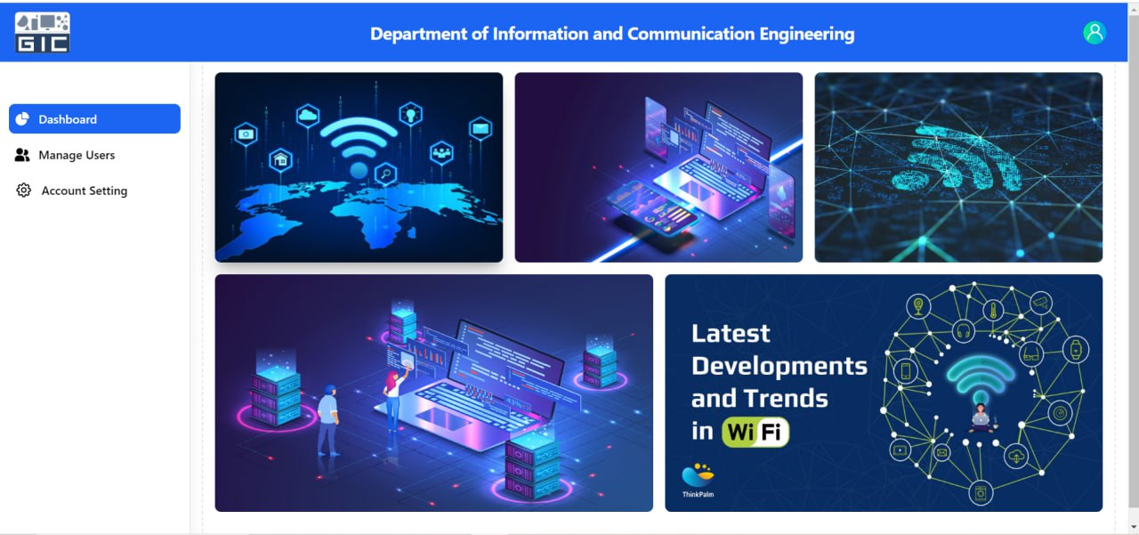

Figure 43: Admin Dashboard

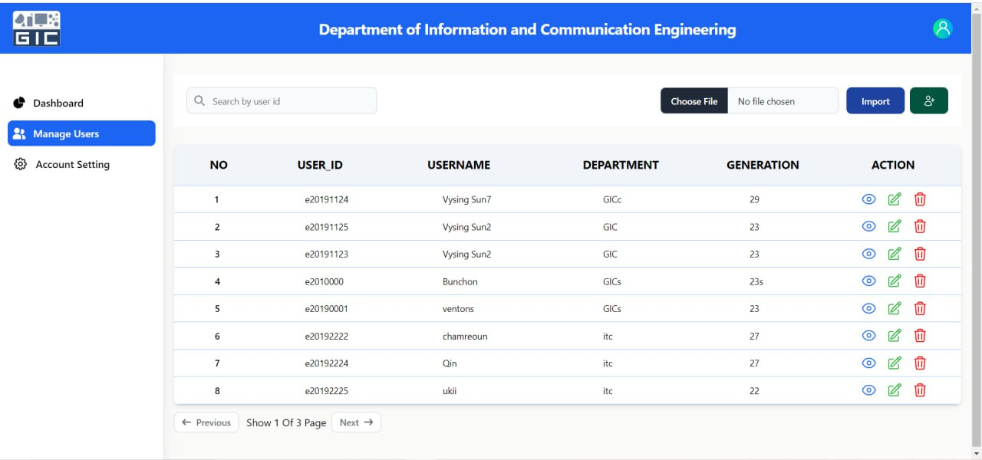

Figure 44: Webpage manage user

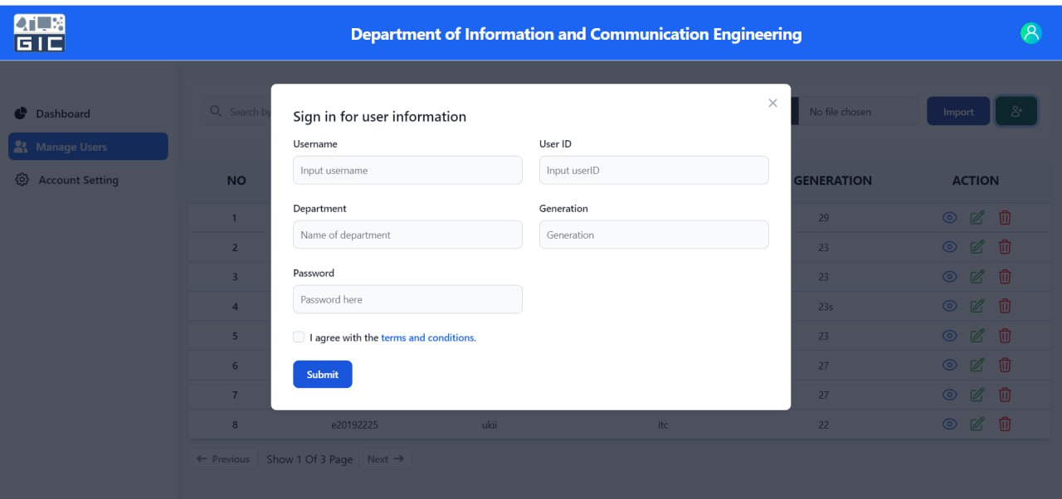

Figure 45: Form add user

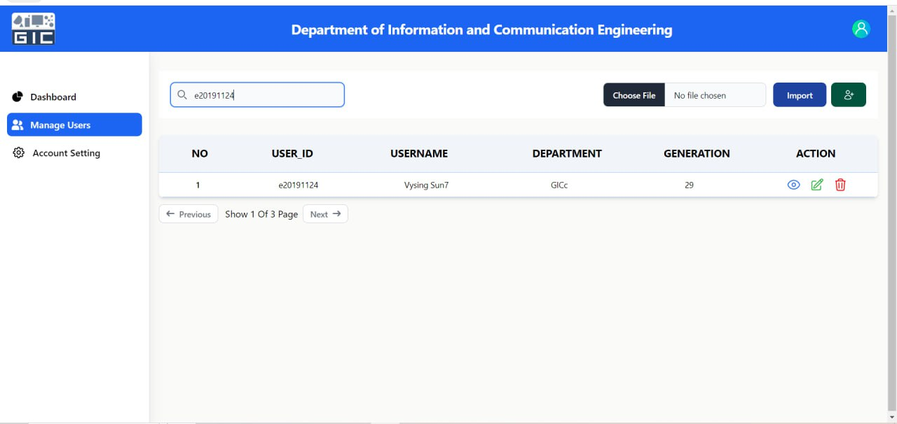

Figure 46: Search user by userId

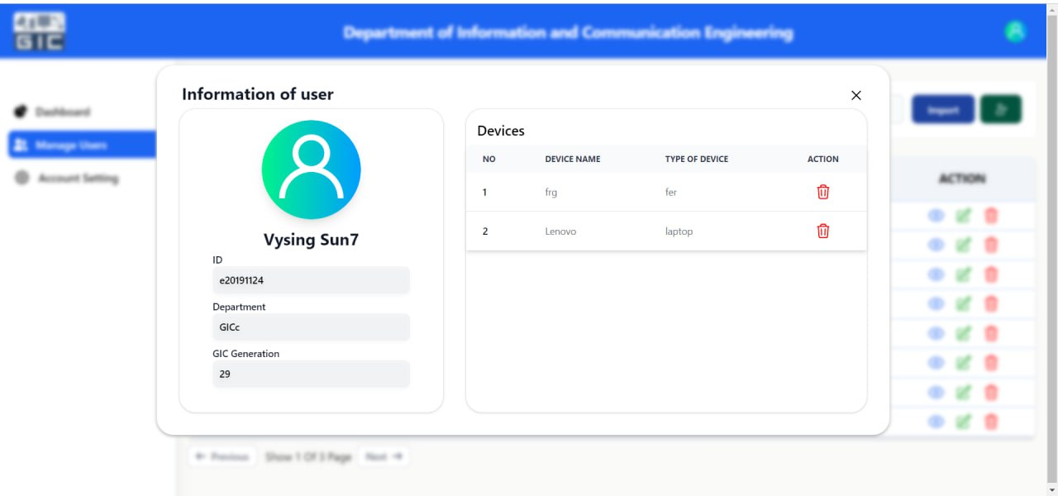

Figure 47: View Information user

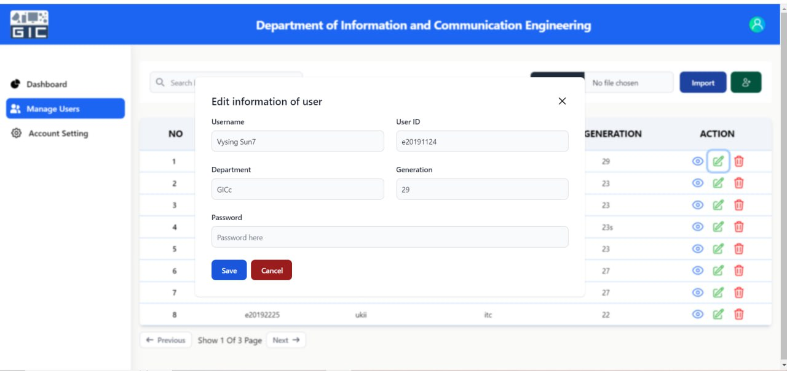

Figure 48: Edit information user

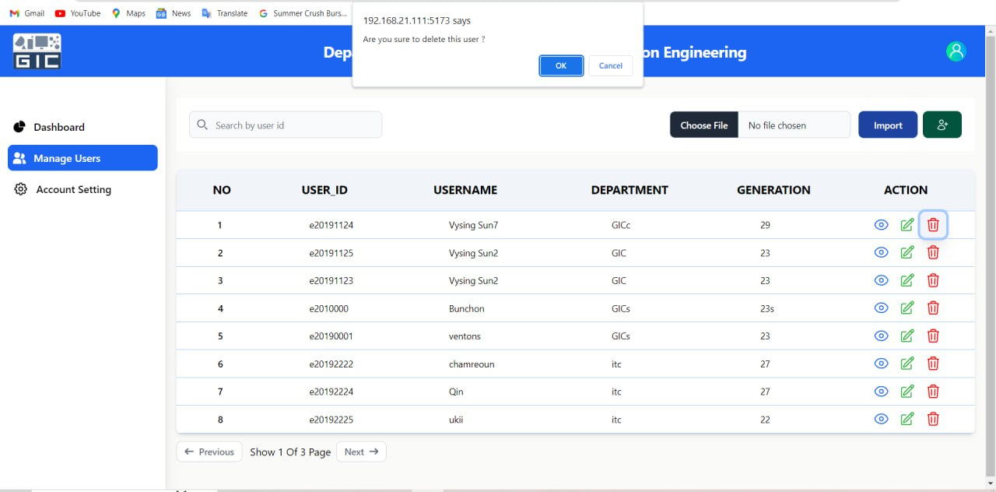

Figure 49: Delete user

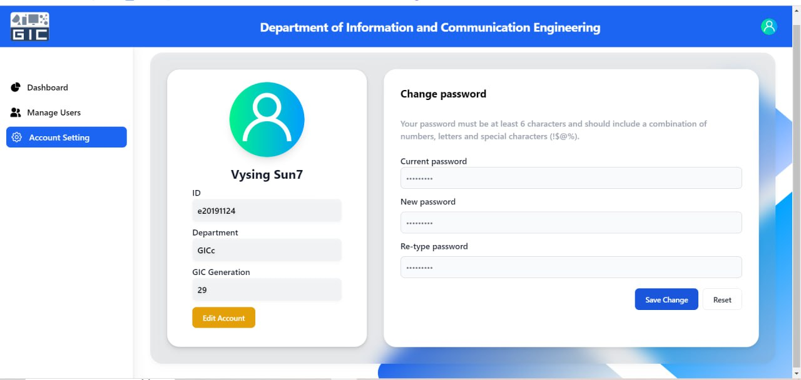

Figure 50: Setting account user

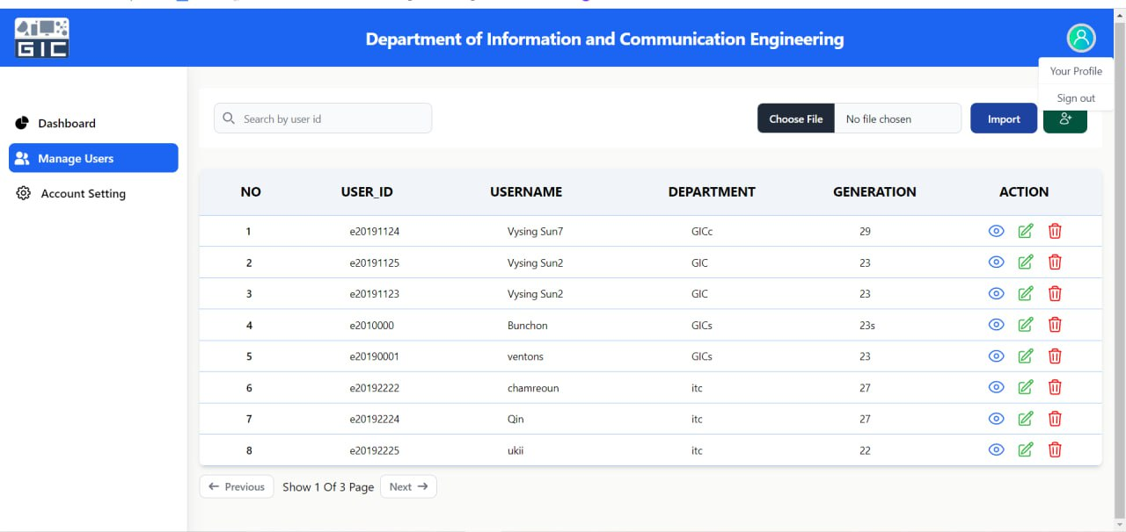

Figure 51: Button logout

# ANNEX B: CAPTURE SCREEN USER

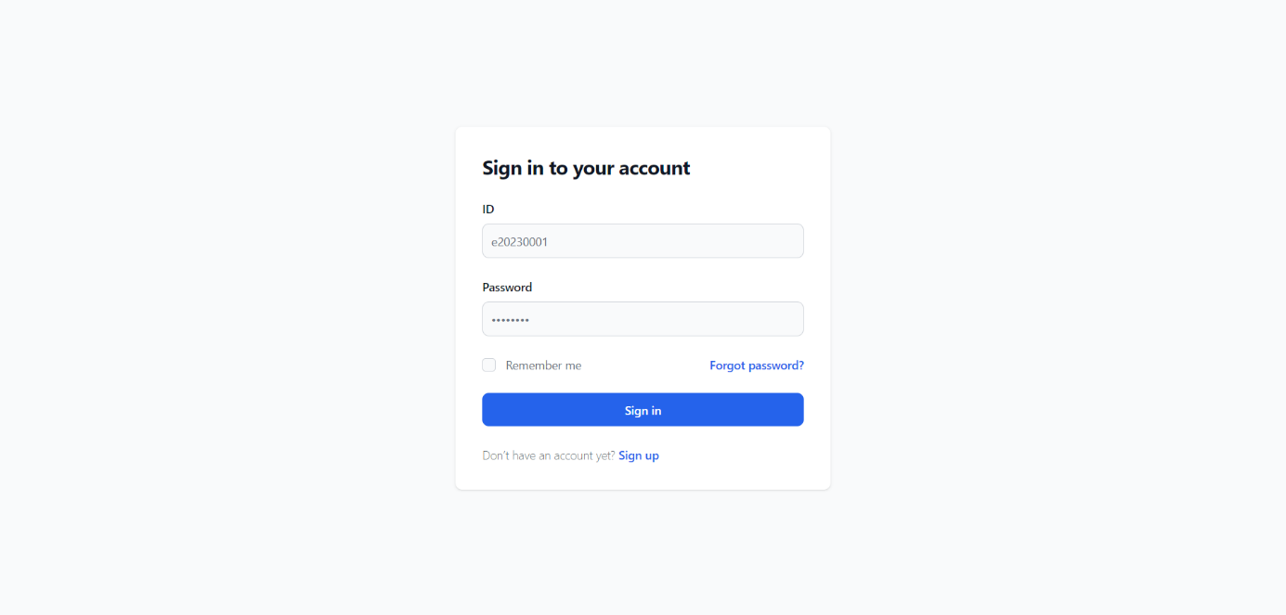

Figure 52: User login

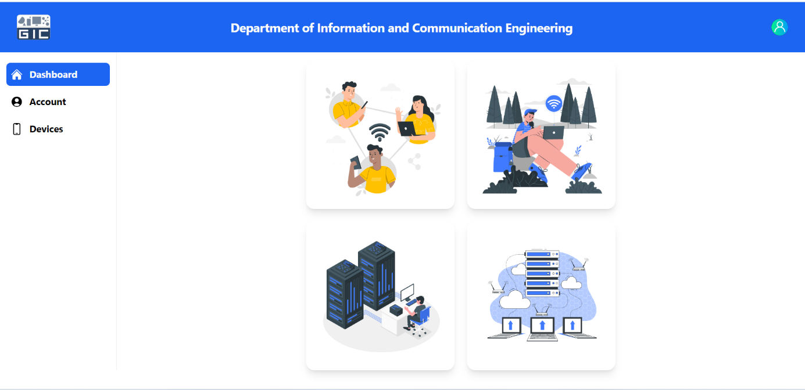

Figure 53: Dashboard User

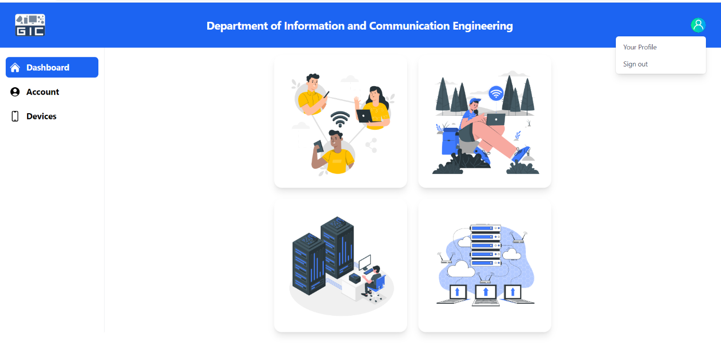

Figure 54: Button logout User

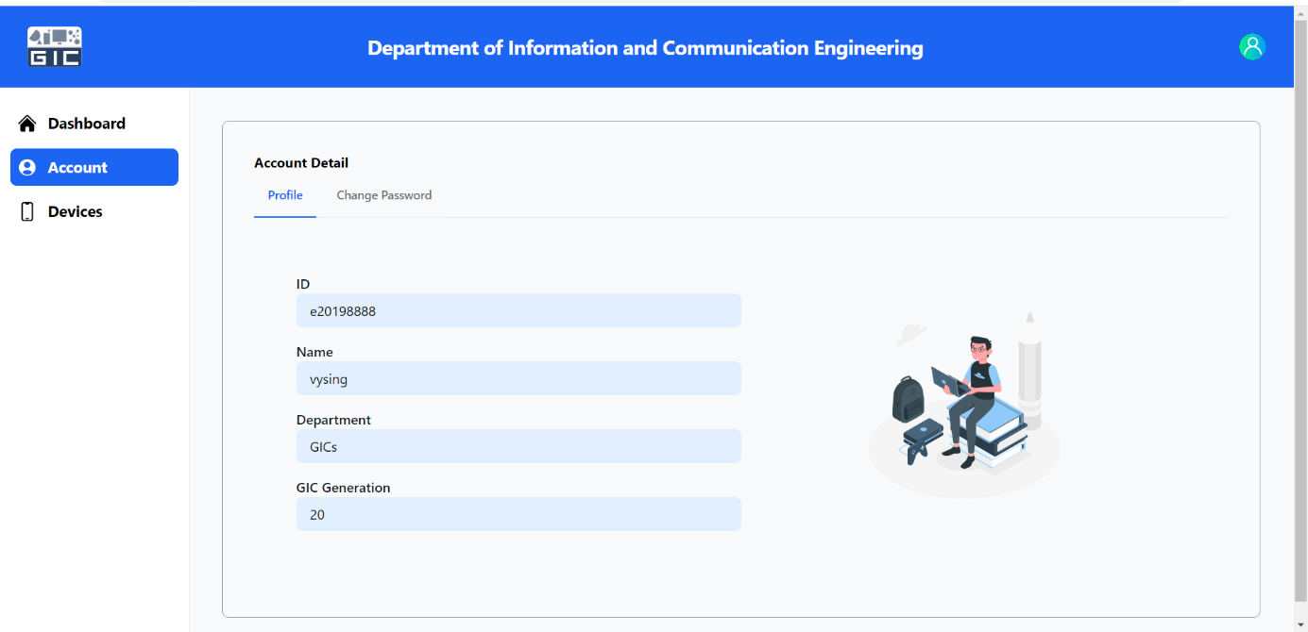

Figure 55: Account User

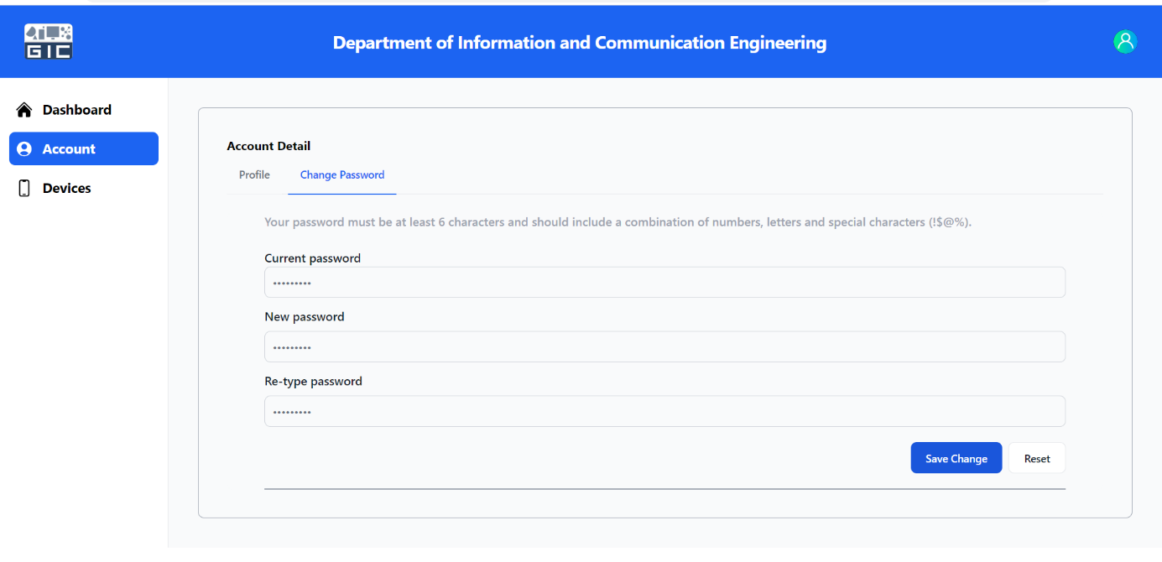

Figure 56: Change Password

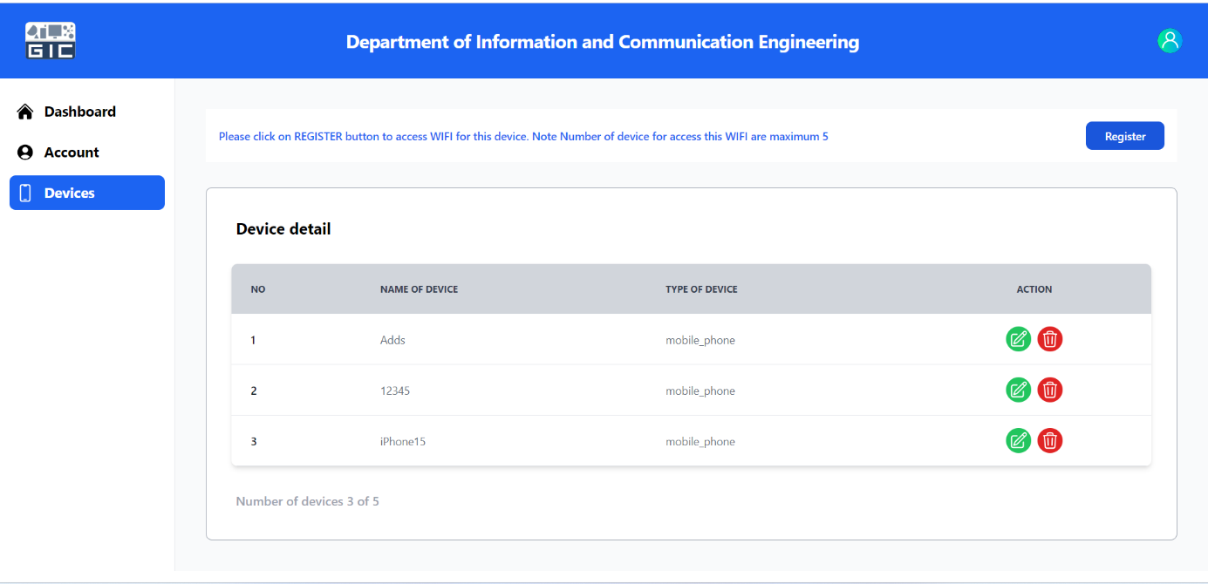

Figure 57: Device of User

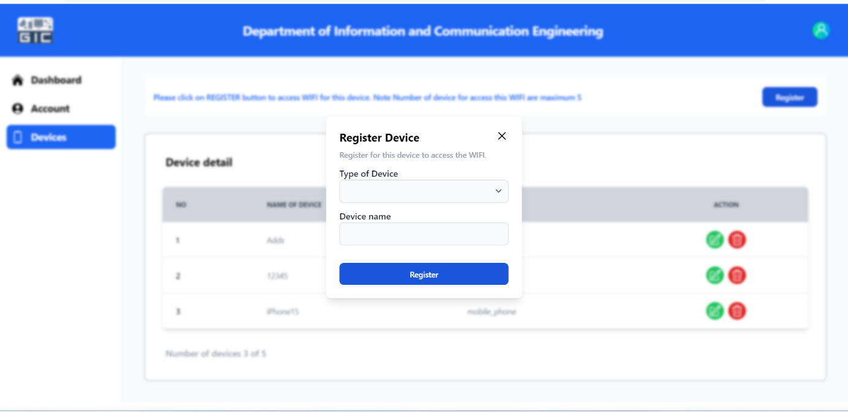

Figure 58: Register device

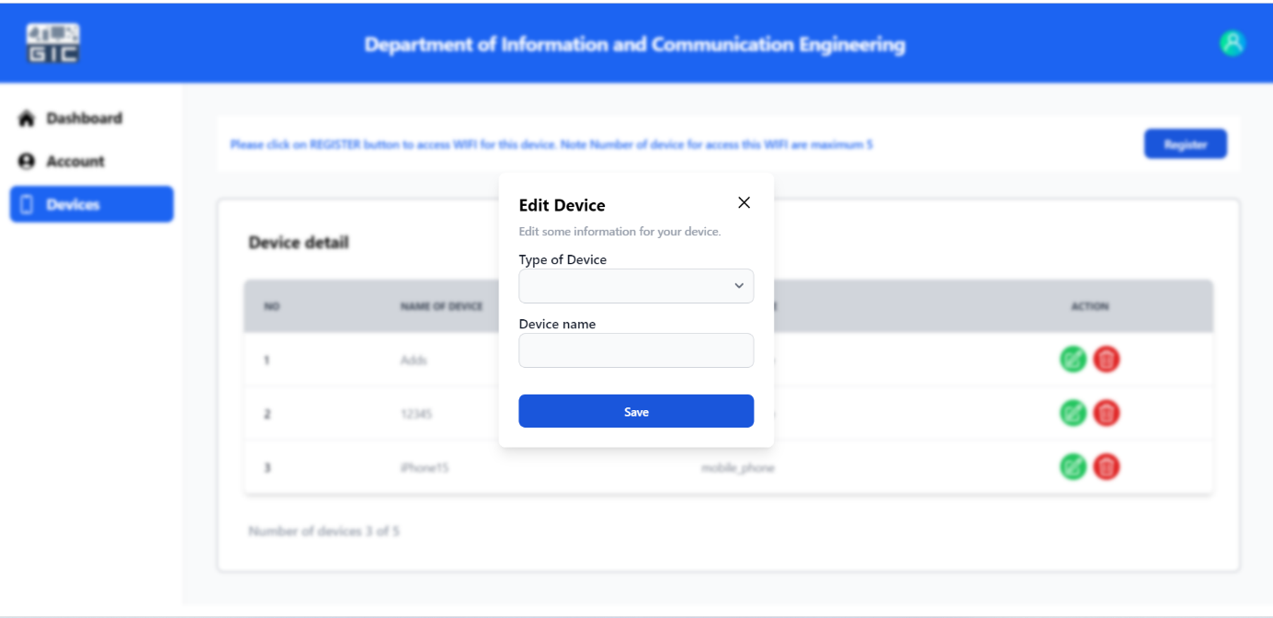

Figure 59: Edit device

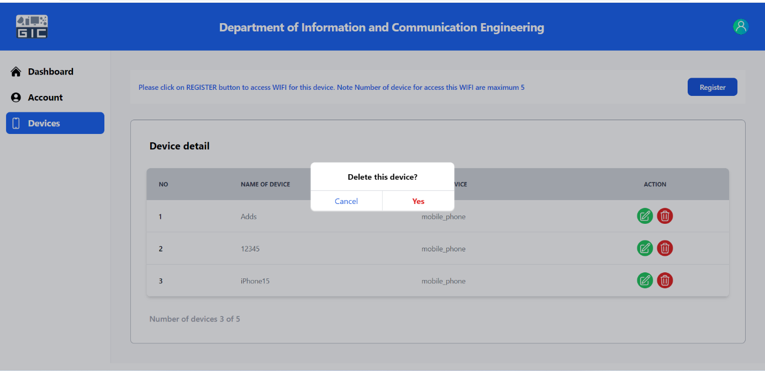

Figure 60: Delete device

# ANNEX C: CAPTURE SCREEN USER ON MOBILE PHONE

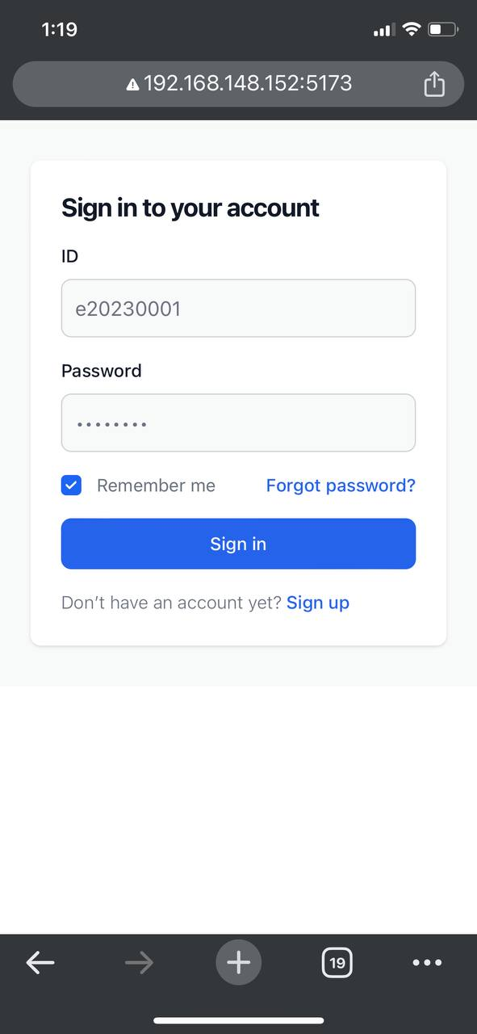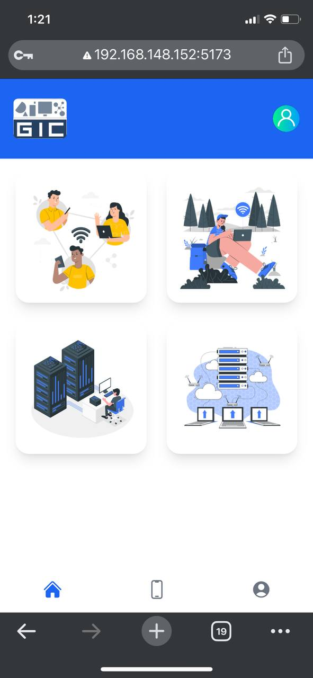

Figure 61: Login by Mobile Phone

Figure 62: User Dashboard

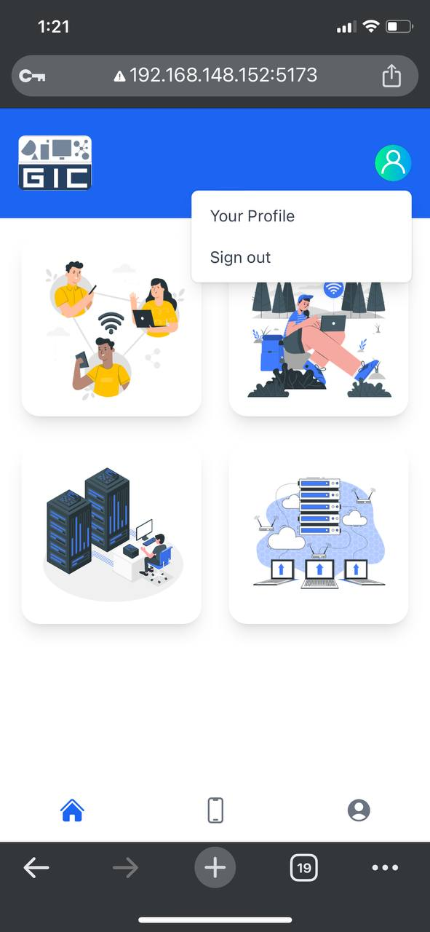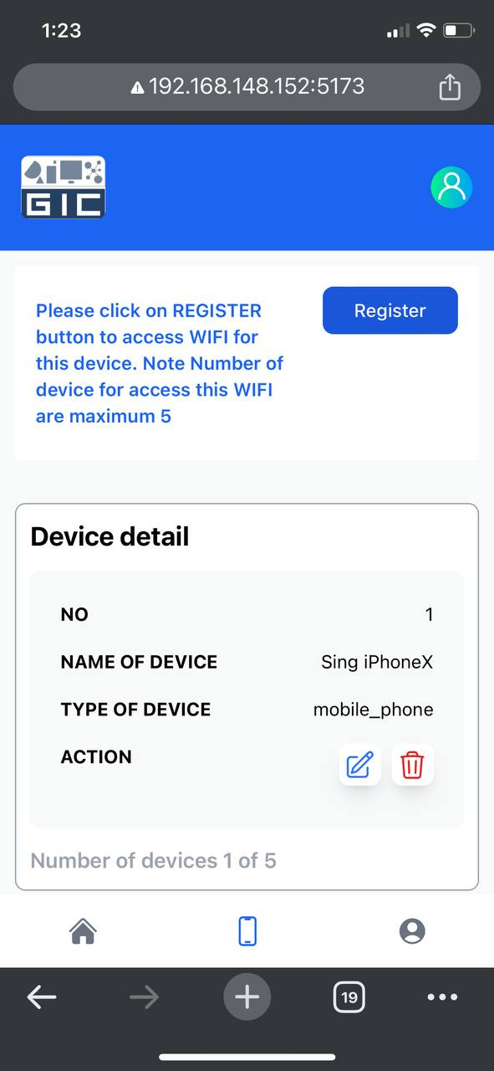

Figure 63: device user

Figure 64: Logout Button

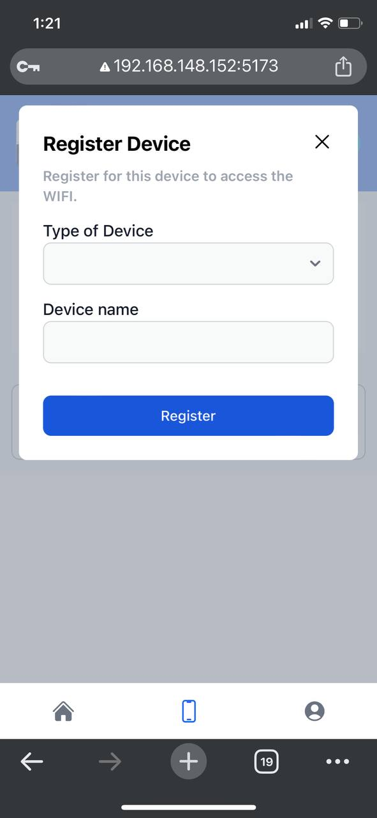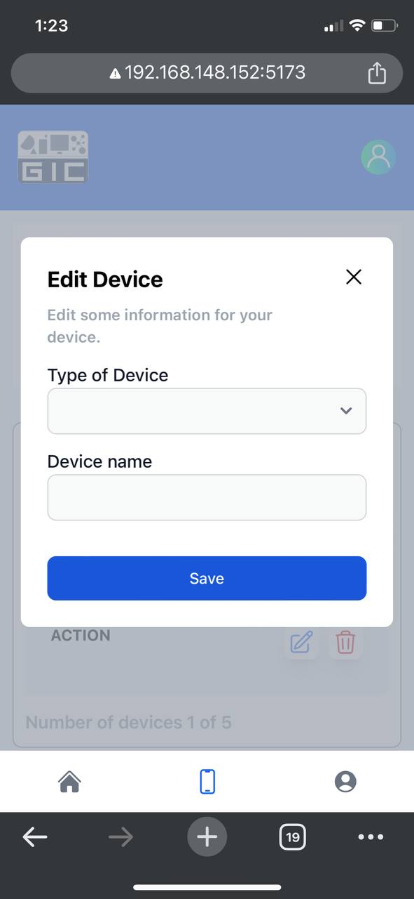

Figure 65: Register device Figure Edit device user

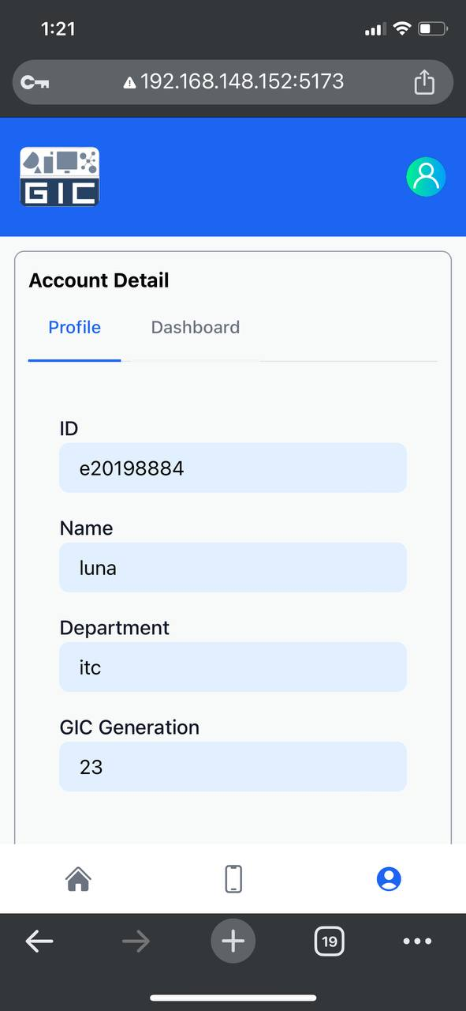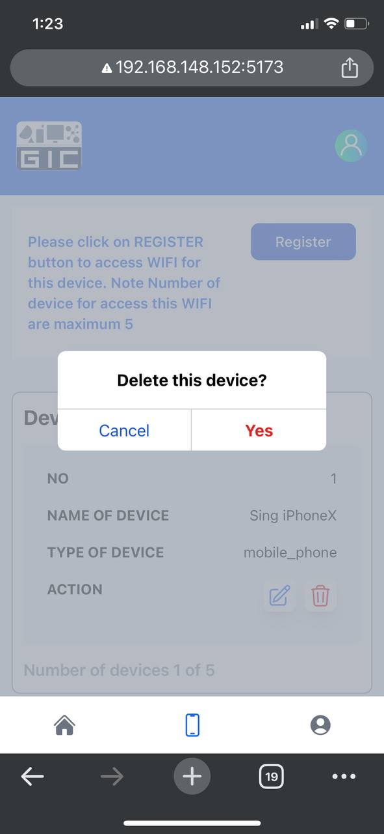

Figure 66: Account user

Figure 67: Delete device

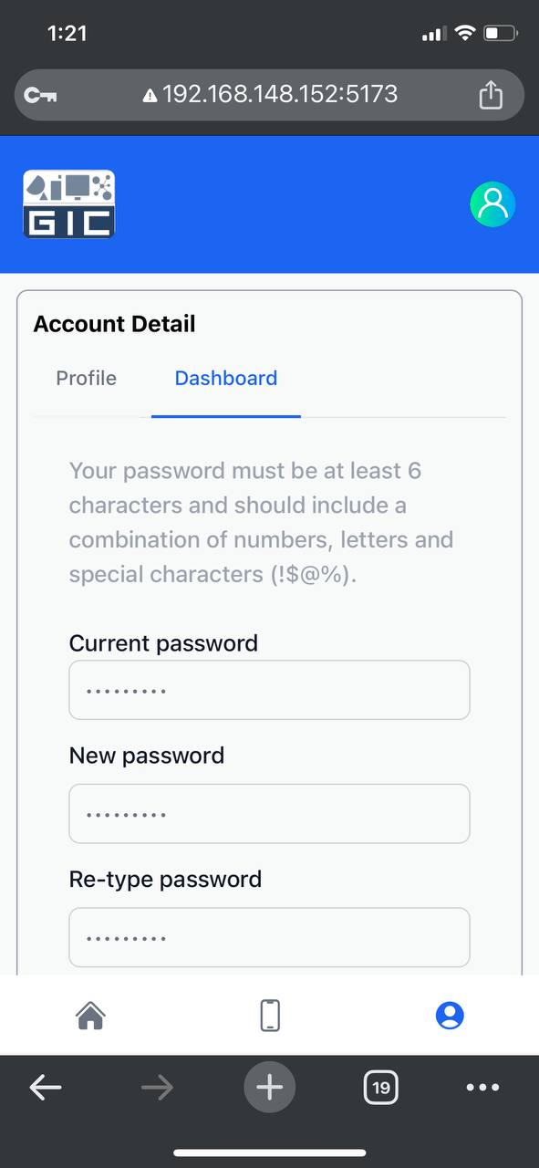

Figure 68: Change Password